Vibrating feeder
Link: Gallery Get this product price
Vibrating feeder is specially designed for evenly feeding the large size material to the crusher. This series vibrating feeder with Vibrating smooth, reliable operation, low noise, small energy consumption, long life, easy maintenance, light weight, small size, easy adjustment and installation, integrated performance, the closed structure of fuselage can prevent dust pollution.
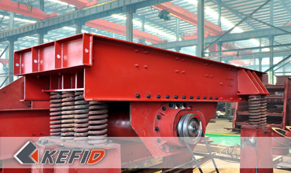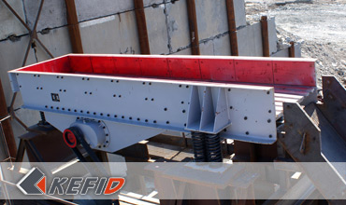

Features of Vibrating feeder
Vibrating feeder with Vibrating smooth, reliable operation, long life;
Exciting force can be adjusted to change at any time and control traffic, adjust stably. Vibratory motor of the Vibrating feeder is excitation source, low noise, small energy consumption, easy maintenance. Simple structure, reliable operation, light weight, small size, the closed structure of fuselage can prevent dust pollution.

Working Principle of Vibrating feeder
Vibrating Feeder Composed by the feeding trough, exciter, spring support, transmission gear, etc. the source of the vibration of the feeding trough is the exciter, which composed by two eccentric shafts (driving and passive) and the gear. The motor drive the driving shaft by V-belt, the gear in the driving shaft meshing the passive shaft, driving shaft and passive shaft reverse rotation at the same time, which make the feed trough vibrating , so that make a continuous flow of materials to achieve the purpose of conveying materials.

Technical Data of Vibrating feeder
Model | Max. feeding  size(mm) | Handling  capacity(t/h) | Power (kW) | Dip angle(º) | Weight(kg)
GZG70-4 | 200 | 120-170 | 2X0.5 | ~10 | 389
GZG100-4 | 300 | 270-380 | 2X1.1 | ~10 | 762
GZD2400X700 | 400 | 30-80 | 2x1.5 | ~10 | 3000
GZD3000×850 | 450 | 80-120 | 2x3.7 | ~9 | 3900
ZSW3800×960 | 500 | 120-210 | 11 | 0 | 3980
ZSW4200×1100 | 580 | 200-430 | 15 | 0 | 4170
ZSW4900×1100 | 580 | 280-500 | 15 | 0 | 4520
ZSW4900×1300 | 650 | 450-600 | 22 | 0 | 5200
ZSW6000×1300 | 650 | 480-800 | 30 | 0 | 7800
ZSW6000×1500 | 800 | 500-850 | 30 | 0 | 8800
Note: Any change of Vibrating feeder technical data shall not be advised additionally.

Our Senior Manager
  Kevin |   Johnny |   Peter
Contact Us
Shanghai | Zhengzhou
Tel: +86-21-58385016  Fax: +86-21-58377628  E-mail: sales@kefidinc.com | Tel: + 86-371-67999255  Fax: +86-371-67998980  E-mail: david@kefidinc.com

Products | Gallery
Mobile Crushing Plant  Crawler Mobile Crusher  Mobile Jaw Crusher  Mobile Impact Crusher  Mobile Cone Crusher  Mobile VSI Crusher  Stationary Crushing Plant  Jaw Crusher  Impact Crusher  Cone Crusher  VSI Crusher  Aggregate Production Line  Stone Crushing Plant  Sand Making Plant  Grinding Mill  Vertical Mill  MTW Series Trapezoid Mill  European Hammer Mill  Micro Powder Mill  Trapezium Mill  High Pressure Mill  Raymond Mill  Ball Mill  Screening & Washing  Vibrating Screen  Screw Sand Washing Machine  Wheel Sand Washing Machine  Feeding & Conveying  Vibrating feeder  Belt Conveyor | Crushing  Mobile Crushing Plant  Stationary Crushing Plant  Jaw Crusher  Impact Crusher  Cone Crusher  VSI Crusher  Aggregate Production Line  Grinding Mill  Vertical Grinding Mill  MTW Series Trapezoid Mill  Micro Powder Mill  Trapezium Mill  High Pressure Mill  Raymond Mill  Ball Mill  European Hammer Mill  Screening & Washing  Vibrating Screen  Sand Washing Machine  Feeding & Conveying  Vibrating Feeder  Belt Conveyor  Delivery of Products  Technology  Workshop  Clients Visit and Exhibiton  Corporate Culture

