Screw Sand Washing Machine
Link: Gallery Get this product price
Kefid screw sand washing machine is mainly used for sand processing, electric pole factory, building work site and concrete dam, various sands classifying and dewatering. It has the novel seal structure, adjustable overflow weir plate, reliable transmission which can ensure the effects of dehydration, suitable for roads, construction and other industries.
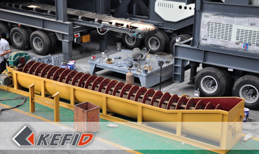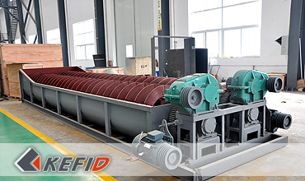

Features of Screw Sand Washing Machine
This sand washing machine adopts inclination of 15º, under the water tub, three weir plates form the sediment pool, the screw head is immersed in this pool, the screw is driven by electric motor through reducer rotating continuously, the fresh water is feeding from porous plate at bottom of sediment pool, this machine have three functions of washing, dewatering, classifying.

Technical Data of Screw Sand Washing Machine
Models | LSX-920 | 2LSX-920 | LSX-1120 | 2LSX-1120
Diameter of screw (mm) | 920 | 920 | 1120 | 1120
Length of tub (mm) | 7585 | 7585 | 9750 | 9750
Feed Size (mm) | ≤10 | ≤10 | ≤10 | ≤10
Capacity (t/h) | 100 | 200 | 175 | 350
Speed of screw (r/min) | 21 | 21 | 17 | 17
Electric Motor Power(kW) | 11 | 2x11 | 18.5 | 2x18.5
Water Consumption (t/h) | 10-80 | 20-160 | 20-150 | 40-300
Dimension (mm)(L×B×H) | 8420×2180×3960 | 8420×3970×3960 | 10770×3950×4860 | 10770×5260×4860
Weight (t) | 6.2 | 11.5 | 10.9 | 17.8
Note: Any change of Screw Sand Washing Machine technical data shall not be advised additionally.

Our Senior Manager
  Kevin |   Johnny |   Peter
Contact Us
Shanghai | Zhengzhou
Tel: +86-21-58385016  Fax: +86-21-58377628  E-mail: sales@kefidinc.com | Tel: + 86-371-67999255  Fax: +86-371-67998980  E-mail: david@kefidinc.com

Products | Gallery
Mobile Crushing Plant  Crawler Mobile Crusher  Mobile Jaw Crusher  Mobile Impact Crusher  Mobile Cone Crusher  Mobile VSI Crusher  Stationary Crushing Plant  Jaw Crusher  Impact Crusher  Cone Crusher  VSI Crusher  Aggregate Production Line  Stone Crushing Plant  Sand Making Plant  Grinding Mill  Vertical Mill  MTW Series Trapezoid Mill  European Hammer Mill  Micro Powder Mill  Trapezium Mill  High Pressure Mill  Raymond Mill  Ball Mill  Screening & Washing  Vibrating Screen  Screw Sand Washing Machine  Wheel Sand Washing Machine  Feeding & Conveying  Vibrating feeder  Belt Conveyor | Crushing  Mobile Crushing Plant  Stationary Crushing Plant  Jaw Crusher  Impact Crusher  Cone Crusher  VSI Crusher  Aggregate Production Line  Grinding Mill  Vertical Grinding Mill  MTW Series Trapezoid Mill  Micro Powder Mill  Trapezium Mill  High Pressure Mill  Raymond Mill  Ball Mill  European Hammer Mill  Screening & Washing  Vibrating Screen  Sand Washing Machine  Feeding & Conveying  Vibrating Feeder  Belt Conveyor  Delivery of Products  Technology  Workshop  Clients Visit and Exhibiton  Corporate Culture

