P Series VSI Crusher
Link: Gallery Get this product price
The P Series VSI Crusher is commonly referred to sand making machine, it is the latest high-energy and low-consumption sand making machine developed on basis of many years ore equipments manufacturing and absorbing principles of the Bamako vertical impact sand making machine. P Series VSI Crusher plays an important role in artificial sand making and mineral crushing.
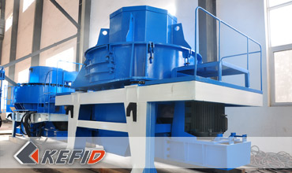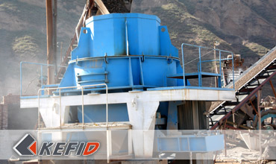

Features of P Series VSI Crusher
1. Simple structure and low operating costs;
2. Low consumption and six models to 320KW;
3. Function of fine crushing and coarse grinding;
4. Slightly influenced by moisture content of material, and the max moisture content is about 8%;
5. More suitable for crushing mid-hardness and hardness materials;
6. Cubic shape of final products, high density of piling up and low iron pollution;
7. Low maintenance and lower wear cost;
8. Low working noise (lower than 75 decibel) and light dust pollution.

Application of P Series VSI Crusher
P Series VSI Crusher is widely used in fine crushing of various ore, especially suitable for making abrasive filler, quartz sand, emery, fire resistant materials, cement, copper ore, furnace slag, river gravel, concrete aggregate, asphalt aggregate and other hard materials to be implemented fine crushing and medium fine crushing. It is a high-efficient sand crushing and sand making machine, which has become the major equipment in sand making industry instead of hammer crusher, roll crusher, roll mill and others.

Technical Data of P Series VSI Crusher
Model | Rotate speed  of impeller  (r/min) | Max feed  size (mm) | Power (kW) | Weight (t) | Capacity (t/h) | Overall  dimensions (mm)
P-600 | 2000-2600 | 30 | 2×30 | 5.6 | 10-30 | 2800×1550×2030
P-750 | 1600-2100 | 35 | 2×45 | 7.5 | 30-50 | 3300×1800×2440
P-900 | 1300-1700 | 40 | 2×55 | 12 | 50-80 | 3750×2120×2660
P-1050 | 1100-1450 | 45 | 2×110 | 16 | 70-120 | 4480×2450×2906
P-1250 | 950-1200 | 45 | 2×132 | 22 | 80-150 | 4563×2650×3176
P-1350 | 800-1200 | 50 | 2×160 | 26 | 120-200 | 5340×2940×3650
Note: Any change of P Series VSI Crusher technical data shall not be advised additionally.

Our Senior Manager
  Kevin |   Johnny |   Peter
Contact Us
Shanghai | Zhengzhou
Tel: +86-21-58385016  Fax: +86-21-58377628  E-mail: sales@kefidinc.com | Tel: + 86-371-67999255  Fax: +86-371-67998980  E-mail: david@kefidinc.com

Products | Gallery
Mobile Crushing Plant  Crawler Mobile Crusher  Mobile Jaw Crusher  Mobile Impact Crusher  Mobile Cone Crusher  Mobile VSI Crusher  Stationary Crushing Plant  Jaw Crusher  Impact Crusher  Cone Crusher  VSI Crusher  Aggregate Production Line  Stone Crushing Plant  Sand Making Plant  Grinding Mill  Vertical Mill  MTW Series Trapezoid Mill  European Hammer Mill  Micro Powder Mill  Trapezium Mill  High Pressure Mill  Raymond Mill  Ball Mill  Screening & Washing  Vibrating Screen  Screw Sand Washing Machine  Wheel Sand Washing Machine  Feeding & Conveying  Vibrating feeder  Belt Conveyor | Crushing  Mobile Crushing Plant  Stationary Crushing Plant  Jaw Crusher  Impact Crusher  Cone Crusher  VSI Crusher  Aggregate Production Line  Grinding Mill  Vertical Grinding Mill  MTW Series Trapezoid Mill  Micro Powder Mill  Trapezium Mill  High Pressure Mill  Raymond Mill  Ball Mill  European Hammer Mill  Screening & Washing  Vibrating Screen  Sand Washing Machine  Feeding & Conveying  Vibrating Feeder  Belt Conveyor  Delivery of Products  Technology  Workshop  Clients Visit and Exhibiton  Corporate Culture

