Mobile VSI Crusher
Link: Gallery Get this product price
Mobile VSI Crusher is widely used in road and bridge construction, city construction, metallurgy, energy and other departments to implement crushing and screening process. Mobile VSI Crusher's prominent features: large capacity, fine crushing and shaping, high efficiency, economic, strong adaptability, crushing and screening processing, self-contained conveyor.
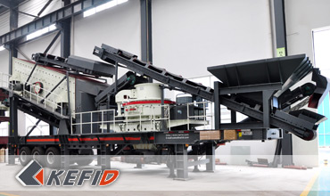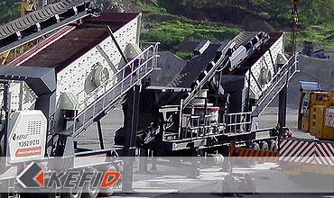

Technical Data of Mobile VSI Crusher
Model Technical data | Y3S184V81 | Y3S186V92 | Y3S216V140
Transportation Length (mm) | 11350 | 15600 | 15600
Transportation Width (mm) | 2830 | 2830 | 3200
Transportation Height (mm) | 4350 | 4350 | 4480
Maximum Length (mm) | 13300 | 14500 | 15000
Maximum Width (mm) | 3150 | 3150 | 3500
Maximum Height (mm) | 6000 | 6400 | 6700
Weight (T) | 31 | 36 | 49
Tire Configuration | Dualaxial | Dualaxial | Triaxial
B series VSI crusher | B-8518 | B-9526 | B-1140
The maximum Feeding size (mm) | 38 | 43 | 59
Capacity (T/h) | 100-260 | 150-380 | 225-520
Belt conveyor under vibraitng screen | B800X7M | B800X8M | B1000X8M
Self-loaded belt conveyor | B800X3M | B1000X3M | B1200X3M
Vbrating screen | 3YZS1848 | 3YZS1860 | 3YZS2160
Note: Any change of Mobile VSI Crusher technical data shall not be advised additionally.

Our Senior Manager
  Kevin |   Johnny |   Peter
Contact Us
Shanghai | Zhengzhou
Tel: +86-21-58385016  Fax: +86-21-58377628  E-mail: sales@kefidinc.com | Tel: + 86-371-67999255  Fax: +86-371-67998980  E-mail: david@kefidinc.com

Products | Gallery
Mobile Crushing Plant  Crawler Mobile Crusher  Mobile Jaw Crusher  Mobile Impact Crusher  Mobile Cone Crusher  Mobile VSI Crusher  Stationary Crushing Plant  Jaw Crusher  Impact Crusher  Cone Crusher  VSI Crusher  Aggregate Production Line  Stone Crushing Plant  Sand Making Plant  Grinding Mill  Vertical Mill  MTW Series Trapezoid Mill  European Hammer Mill  Micro Powder Mill  Trapezium Mill  High Pressure Mill  Raymond Mill  Ball Mill  Screening & Washing  Vibrating Screen  Screw Sand Washing Machine  Wheel Sand Washing Machine  Feeding & Conveying  Vibrating feeder  Belt Conveyor | Crushing  Mobile Crushing Plant  Stationary Crushing Plant  Jaw Crusher  Impact Crusher  Cone Crusher  VSI Crusher  Aggregate Production Line  Grinding Mill  Vertical Grinding Mill  MTW Series Trapezoid Mill  Micro Powder Mill  Trapezium Mill  High Pressure Mill  Raymond Mill  Ball Mill  European Hammer Mill  Screening & Washing  Vibrating Screen  Sand Washing Machine  Feeding & Conveying  Vibrating Feeder  Belt Conveyor  Delivery of Products  Technology  Workshop  Clients Visit and Exhibiton  Corporate Culture

