Mobile Jaw Crusher
Link: Gallery Get this product price
Mobile jaw crusher is the newest rock crushing equipment, mainly used in metallurgy, chemical industry ,building materials, hydroelectric power and material processing that often requires removal working, especially for highways, railways, hydroelectric subjects. The users can adopt a variety of configurations according to different type of raw materials, different requirements for scale and final product materials. Jaw crusher station has greatly expanded the concept of coarse crushing areas.
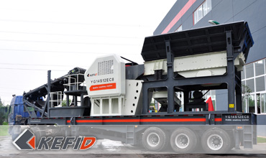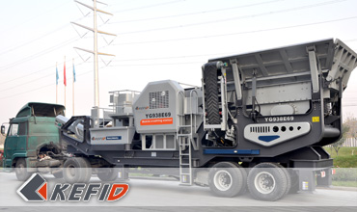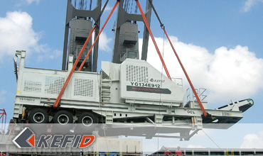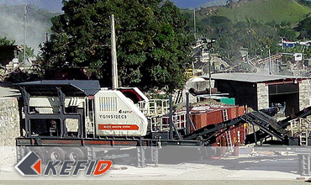

Features of Mobile Jaw Crusher
1. High-performance crusher, great crushing ratio, and powerful crushing pioneer.
2. Truck-mounted motor and integrated control box.
3. Work with the integrated machines of jaw crusher, cone crusher, vertical impact crusher, feeders and vibrating screens.
4. With vehicle installation of sieve under the belt, vibrating screener and crusher.
5. Support of vehicle installation and settlement of equipments are prompt and convenient.
6. Steering traction axis will be helpful for high way transportation and getting close to the working site.

Technical Data of Mobile Jaw Crusher
Model Technical data | YG830E46 | YG938E57 | YG938E69 | YG1142E710 | YG134E912 | YG134J811
Transportation Length (mm)  (If there is an diesel generator) | 8600 | 9800 | 11900 | 13100 | 14000 | 14600
Transportation Width (mm) | 2450 | 2450 | 2550 | 2550 | 2950 | 2550
Transporation Height (mm) | 3800 | 3500 | 3650 | 4450 | 4500 | 4500
Maximum Length (mm) | 12000 | 13300 | 12100 | 13300 | 14600 | 14600
Maximum Width (mm) | 2800 | 2900 | 2900 | 2950 | 3300 | 3300
Maximum Height (mm) | 3800 | 4100 | 4060 | 4810 | 5300 | 5300
Weight (T) | 26 | 32 | 41 | 55 | 81 | 65
Tire Configuration | Dualaxial | Dualaxial | Dualaxial | Triaxial | Triaxial | Triaxial
Jaw crusher | PE400  ×600 | PE500  ×750 | PE600  ×900 | PE750  ×1060 | PE900  ×1200 | JC840  ×1100
The maximum Feeding size (mm) | 350 | 425 | 480 | 630 | 750 | 720
Discharge opening size(mm) | 40-100 | 50-100 | 65-160 | 80-140 | 95-165 | 100-225
Capacity (T/h) | 15-60 | 50-100 | 90-180 | 110-320 | 220-450 | 200-500
Vibrating Feeder | ZSW850  ×3000 | ZSW960  ×3800 | ZSW960  ×3800 | ZSW1100  ×4200 | ZSW1300  ×4900 | ZSW1300  ×4900
Belt conveyor | B650×7M | B650×7.5M | B800×8.5M | B1000×9M | B1200×9.5M | B1200×9.5M
Note: Any change of Mobile Jaw Crusher technical data shall not be advised additionally.

Our Senior Manager
  Kevin |   Johnny |   Peter
Contact Us
Shanghai | Zhengzhou
Tel: +86-21-58385016  Fax: +86-21-58377628  E-mail: sales@kefidinc.com | Tel: + 86-371-67999255  Fax: +86-371-67998980  E-mail: david@kefidinc.com

Products | Gallery
Mobile Crushing Plant  Crawler Mobile Crusher  Mobile Jaw Crusher  Mobile Impact Crusher  Mobile Cone Crusher  Mobile VSI Crusher  Stationary Crushing Plant  Jaw Crusher  Impact Crusher  Cone Crusher  VSI Crusher  Aggregate Production Line  Stone Crushing Plant  Sand Making Plant  Grinding Mill  Vertical Mill  MTW Series Trapezoid Mill  European Hammer Mill  Micro Powder Mill  Trapezium Mill  High Pressure Mill  Raymond Mill  Ball Mill  Screening & Washing  Vibrating Screen  Screw Sand Washing Machine  Wheel Sand Washing Machine  Feeding & Conveying  Vibrating feeder  Belt Conveyor | Crushing  Mobile Crushing Plant  Stationary Crushing Plant  Jaw Crusher  Impact Crusher  Cone Crusher  VSI Crusher  Aggregate Production Line  Grinding Mill  Vertical Grinding Mill  MTW Series Trapezoid Mill  Micro Powder Mill  Trapezium Mill  High Pressure Mill  Raymond Mill  Ball Mill  European Hammer Mill  Screening & Washing  Vibrating Screen  Sand Washing Machine  Feeding & Conveying  Vibrating Feeder  Belt Conveyor  Delivery of Products  Technology  Workshop  Clients Visit and Exhibiton  Corporate Culture

