Micro Powder Mill
Link: Gallery Get this product price
HGM series micro powder mill is processing equipment for fine powder and super fine powder. The micro powder mill's mainly used to grind non-flammable, non-explosive non-mental materials with medium and low hardness, temperature below 6%, and mohs hardness below 9 degrees.
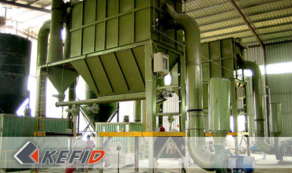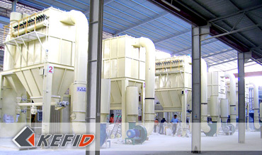

Features of Micro Powder Mill
1. Low cost. With same fineness and motor power, it invest less comparing with airflow mill, stirring mill, ball mill, which is of low cost, short recovery period and twice more production capacity.
2. High powder outlet ratio. With same product fineness and energy consumption, the capacity is 45% higher than that of airflow mill and stirring mill.
3. Less loss of wearable parts, long service life. All wearable parts are of high-quality abrasion resistant materials both at home and abroad, the service life of which is longer than ordinary mill, generally more than one year.
4. High security and reliability, running safely and stably in the grinding cavity. Comparing with ordinary mill, the super fine mill has advantages of no rolling draft, no bolts. Thus, there is no problem of weariness of drafts and other seal parts, which can avoid bolts loosing and machine damage.
5. High fineness of final product. Final fineness can reach d97≤5μm.
6. Environmental conservation. High efficient pulse dust removing device is adopted, which can guarantee little dust pollution of the whole equipment. Silencer room is allocated, which will reduce dust pollution and noise, meeting the national environment protection standard, and protecting the surrounding environment.

Technical Data of Micro Powder Mill
Mm to inch conversion: 25.4millimeters=1 inch
The humidity and hardness of raw material will affect the fineness and capacity.
Model | HGM80 | HGM100
Roller number | 21 | 27
Diameter (mm) | Φ800 | Φ1000
Ring number | 3 | 3
Main unit speed(mm) | 180-235 | 150-200
Max. feeding size(mm) | <10 | <10
Final size (mesh) | 300-3000 | 300-3000
Capacity (kg/h) | 500-3500 | 900-6500
Overall dimension (m) | 12.4×3.5×5.8 | 14.5×5.0×8.6
Note: Any change of Micro Powder Mill technical data shall not be advised additionally.

Our Senior Manager
  Kevin |   Johnny |   Peter
Contact Us
Shanghai | Zhengzhou
Tel: +86-21-58385016  Fax: +86-21-58377628  E-mail: sales@kefidinc.com | Tel: + 86-371-67999255  Fax: +86-371-67998980  E-mail: david@kefidinc.com

Products | Gallery
Mobile Crushing Plant  Crawler Mobile Crusher  Mobile Jaw Crusher  Mobile Impact Crusher  Mobile Cone Crusher  Mobile VSI Crusher  Stationary Crushing Plant  Jaw Crusher  Impact Crusher  Cone Crusher  VSI Crusher  Aggregate Production Line  Stone Crushing Plant  Sand Making Plant  Grinding Mill  Vertical Mill  MTW Series Trapezoid Mill  European Hammer Mill  Micro Powder Mill  Trapezium Mill  High Pressure Mill  Raymond Mill  Ball Mill  Screening & Washing  Vibrating Screen  Screw Sand Washing Machine  Wheel Sand Washing Machine  Feeding & Conveying  Vibrating feeder  Belt Conveyor | Crushing  Mobile Crushing Plant  Stationary Crushing Plant  Jaw Crusher  Impact Crusher  Cone Crusher  VSI Crusher  Aggregate Production Line  Grinding Mill  Vertical Grinding Mill  MTW Series Trapezoid Mill  Micro Powder Mill  Trapezium Mill  High Pressure Mill  Raymond Mill  Ball Mill  European Hammer Mill  Screening & Washing  Vibrating Screen  Sand Washing Machine  Feeding & Conveying  Vibrating Feeder  Belt Conveyor  Delivery of Products  Technology  Workshop  Clients Visit and Exhibiton  Corporate Culture

