HP Cone Crusher
Link: Gallery Get this product price
The HP cone crusher is the globally advanced and high-performance cone crusher developed by absorbing the latest Germanic technology, which is widely used in metal and nonmetal ore, cement factory, sand and stone metallurgy industries. HP cone crusher has not only increased the productivity and crushing effect, but also expand the using field, from limestone to basalt, from stone production to various stone crushing.
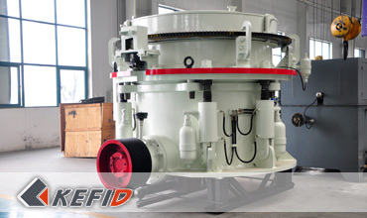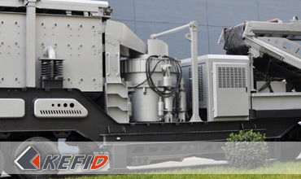

Features of HP Cone Crusher
HP Cone Crusher can complete various medium fine, fine and super fine operation with high efficiency, easy to maintain and embrace great reliable operation. It is the latest product for replacement of spring cone crusher and common hydraulic crusher in the modern ore and construction industries, and a optimum equipment for grand scale stone processing factory and ore crushing.
The high efficient hydraulic cone crusher is a high-efficient cone crusher developed by absorbing the Germanic technology, it has the following features:
1. High efficiency: this machine adopts the fixed main draft, equal small spherical axis and other perfected structure, comparing with the old spring cone crusher, efficiency has been increased by 5%-15%.
2. Big capacity: this machine is a perfect combination of crushing stroke, crushing speed and crushing chamber, which makes the capacity 35%-60% more than that of the old spring cone crusher while size of crushing cone is the same.
3. High-quality pebble: this machine adopts the lamination crushing principle, there will be crushing function happening between different kernels, so that proportion of cubic shaped products can be obviously high, needle-like stones will be less, and grain grade will be more even.
4. More stable performance: while there are materials not suitable for crushing entering into the machine, the protection device will start automatically to relieve it and reset immediately.
5. The multi-split hydraulic lubrication control system will ensure a double protection to draft lubrication and a over-load protection.

Technical Data of HP Cone Crusher
Type | Cavity  (coarse/fine) | Min. discharge  size (mm) | Feed size  (mm) | Capacity (t/h) | Power  (kW) | Weight  (t) | movable cone  diameter (mm)
HP-160 | C | 13 | 150 | 120-240 | 160 | 13 | 950
HP-160 | F | 6 | 76 | 55-180 | 160 | 13 | 950
HP-220 | C | 13 | 225 | 150-430 | 220 | 18 | 1160
HP-220 | F | 6 | 86 | 90-260 | 220 | 18 | 1160
HP-315 | C | 13 | 290 | 190-610 | 315 | 26 | 1400
HP-315 | F | 6 | 100 | 108-320 | 315 | 26 | 1400
HP-400 | C | 13 | 320 | 230-700 | 400 | 33 | 1500
Note: Any change of HP Cone Crusher technical data shall not be advised additionally.

Our Senior Manager
  Kevin |   Johnny |   Peter
Contact Us
Shanghai | Zhengzhou
Tel: +86-21-58385016  Fax: +86-21-58377628  E-mail: sales@kefidinc.com | Tel: + 86-371-67999255  Fax: +86-371-67998980  E-mail: david@kefidinc.com

Products | Gallery
Mobile Crushing Plant  Crawler Mobile Crusher  Mobile Jaw Crusher  Mobile Impact Crusher  Mobile Cone Crusher  Mobile VSI Crusher  Stationary Crushing Plant  Jaw Crusher  Impact Crusher  Cone Crusher  VSI Crusher  Aggregate Production Line  Stone Crushing Plant  Sand Making Plant  Grinding Mill  Vertical Mill  MTW Series Trapezoid Mill  European Hammer Mill  Micro Powder Mill  Trapezium Mill  High Pressure Mill  Raymond Mill  Ball Mill  Screening & Washing  Vibrating Screen  Screw Sand Washing Machine  Wheel Sand Washing Machine  Feeding & Conveying  Vibrating feeder  Belt Conveyor | Crushing  Mobile Crushing Plant  Stationary Crushing Plant  Jaw Crusher  Impact Crusher  Cone Crusher  VSI Crusher  Aggregate Production Line  Grinding Mill  Vertical Grinding Mill  MTW Series Trapezoid Mill  Micro Powder Mill  Trapezium Mill  High Pressure Mill  Raymond Mill  Ball Mill  European Hammer Mill  Screening & Washing  Vibrating Screen  Sand Washing Machine  Feeding & Conveying  Vibrating Feeder  Belt Conveyor  Delivery of Products  Technology  Workshop  Clients Visit and Exhibiton  Corporate Culture

