Crawler Mobile Crusher
Link: Gallery Get this product price
Hydraulic driven crawler mobile crushing plant is a crushing and screening equipments with hydraulic driven crawler vehicle chassis walking which research and develop by KEFID oriented to market requirements. It is of high cost performance, high reliability and beautiful appearance. Its technology has achieved the international level. It is widely used in road construction, urban construction, metallurgy, energy department and other fields to do crushing and screening.
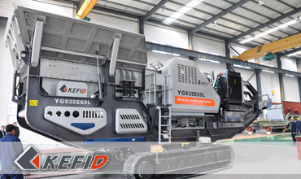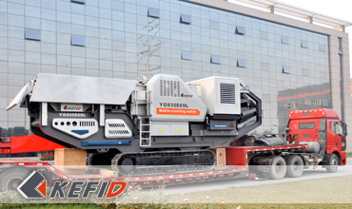
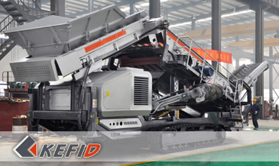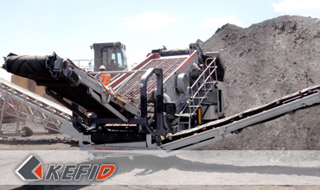

Features of Crawler Mobile Crusher
1. Excellent performance of Cummins diesel engine. It is low consumption, low noise, reliable performance, which can provide us with reliable, economical and environmental-friendly energy source. A military preheat starting device under low temperature can be equipped, which will enable the equipment to start easily while the temperature is below -25C°
2. The chassis is of crawler total-rigid ship-shape structure, which is of high intensity, excellent crawling ability, and have a good adaptability like mountains and wetlands.
3. Mature technology of crawling motor with large torque, which is of powerful and high reliability. The crawling system adopts full-power variable opening hydraulic system, which is perfect in performance, reliable and is able to fully utilize the power of motor. Main hydraulic parts (pump, valve) are all imported from Japan.
4. Control system adopts imported servo pilot operation system with light manipulate and accurate controlling which can realize non-polar walking speed.
5. Crushing and screening equipments select the mature products produced by our company, which has compact structure and stable performance. Screening equipments adopts 20°obiquity which makes screening efficient and reliable.

Technical Data of Crawler Mobile Crusher
Mobile Jaw Crushing Plant:
Vibrating Feeder | GZD-960X3800 | GZD-1100X4200 | GZD-960X3800
Jaw Crusher | PE600X900 | PE750X1060 | PE500X750
Main Belt Width (mm) | 800 | 1000 | 650
Main Belt Discharge Height (mm) | 3200 | 3500 | 2700
Side Belt Width (mm) | 450 | 500 | 500
Side Belt Discharge Height (mm) | 2800 | 3100 | 2700
Power (KW) | 180 | 200 | 150
Transportation Length (mm) | 11900 | 13300 | 12500
Transportation Width (mm) | 3100 | 3100 | 3050
Transporation Height (mm) | 3650 | 4500 | 3400
Transporation Weight (T) | 43.5 | 59 | 33
Mobile Impact Crushing Plant:
Vibrating Feeder | GZD-960X3800 | GZD-960X3800 | GZD-960X3800
Impact Crusher | PF1010 | PF1210 | PF1214
Main Belt Width (mm) | 800 | 800 | 1000
Main Belt Discharge Height (mm) | 2700 | 2700 | 2700
Side Belt Width (mm) | 500 | 500 | 500
Side Belt Discharge Height (mm) | 2700 | 2700 | 2700
Power (KW) | 150KW | 200 | 300
Transportation Length (mm) | 12000 | 13000 | 13000
Transportation Width (mm) | 3050 | 3050 | 3050
Transporation Height (mm) | 3500 | 3800 | 3800
Transporation Weight (T) | 36 | 42 | 48
Mobile Cone Crushing Plant:
Cone Crusher | CS75 | CS160 | HP220
Vibrating Feeder | GLD1500/4 | GLD1500/5 | GLD1500/5
Up Hopper Volume (M³) | 4 | 5 | 5
Feeding Height (mm) | 2900 | 2900 | 3100
Main Belt Width (mm) | 800 | 1000 | 1000
Main Belt Discharge Height (mm) | 2600 | 2800 | 3100
Power (KW) | 150KW | 300KW | 330KW
Transportation Length (mm) | 12000 | 12500 | 12500
Transportation Width (mm) | 3240 | 3050 | 3240
Transporation Height (mm) | 3700 | 3900 | 3900
Transporation Weight (T) | 35.4 | 45 | 41.4
Mobile Vibrating Screen Plant:
Vibrating Screen | 2YZS1848 | 3YZS1860 | 3YZS2160
Closed hopper volume (M³) | 5 | 6 | 8
Closed hopper Height (mm) | 4300 | 5000 | 5000
Feeding Belt | B800X7.2 | B1000X12 | B1000X8.5
Screen Under Belt | B800X7 | B1000X8 | B1000X8
Screen Under Belt Discharge Height (mm) | 3500 | 3500 | 3500
Side Blet | B500X5 | B650X5 | B650X5
Side Blet Discharge Height (mm) | 3500 | 3500 | 3500
Front Belt | B650X7 | B800X8 | B800X8
Front Belt Discharge Height (mm) | 2800 | 3000 | 3000
Power (KW) | 120 | 150 | 180
Transportation Length (mm) | 12000 | 13500 | 1400
Transportation Width (mm) | 3050 | 3200 | 3400
Transporation Height (mm) | 3500 | 4100 | 4100
Transporation Weight (T) | 30 | 36 | 42
Note: Any change of Crawler Mobile Crusher technical data shall not be advised additionally.

Our Senior Manager
  Kevin |   Johnny |   Peter
Contact Us
Shanghai | Zhengzhou
Tel: +86-21-58385016  Fax: +86-21-58377628  E-mail: sales@kefidinc.com | Tel: + 86-371-67999255  Fax: +86-371-67998980  E-mail: david@kefidinc.com

Products | Gallery
Mobile Crushing Plant  Crawler Mobile Crusher  Mobile Jaw Crusher  Mobile Impact Crusher  Mobile Cone Crusher  Mobile VSI Crusher  Stationary Crushing Plant  Jaw Crusher  Impact Crusher  Cone Crusher  VSI Crusher  Aggregate Production Line  Stone Crushing Plant  Sand Making Plant  Grinding Mill  Vertical Mill  MTW Series Trapezoid Mill  European Hammer Mill  Micro Powder Mill  Trapezium Mill  High Pressure Mill  Raymond Mill  Ball Mill  Screening & Washing  Vibrating Screen  Screw Sand Washing Machine  Wheel Sand Washing Machine  Feeding & Conveying  Vibrating feeder  Belt Conveyor | Crushing  Mobile Crushing Plant  Stationary Crushing Plant  Jaw Crusher  Impact Crusher  Cone Crusher  VSI Crusher  Aggregate Production Line  Grinding Mill  Vertical Grinding Mill  MTW Series Trapezoid Mill  Micro Powder Mill  Trapezium Mill  High Pressure Mill  Raymond Mill  Ball Mill  European Hammer Mill  Screening & Washing  Vibrating Screen  Sand Washing Machine  Feeding & Conveying  Vibrating Feeder  Belt Conveyor  Delivery of Products  Technology  Workshop  Clients Visit and Exhibiton  Corporate Culture

