Wheel Sand Washing Machine
Link: Gallery Get this product price
The Wheel Sand Washing Machine is bucket-washing equipment, which is able to wash and separate powder soil in sand and stones. It has an innovative seal structure, reliable transmission device, which is able to guarantee effect of cleaning and dehydration, and is high-efficient sand washing equipment which can be used by matching sand making machine.
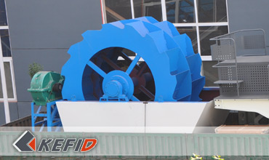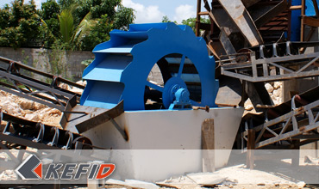

Features of Wheel Sand Washing Machine
1. It is simple in structure, stable in performance, and has high wash degree, less loss in sand washing process, especially while transmission device is separated from water and sand, failure rate is greatly lower than recent sand washing machine, and it has long life span.
2. It has reasonable structure, innovative seal structure, totally sealed oil bath gear, adjustable overflow weir plate, which can guarantee products with high efficiency, durability, good washing and dehydration effect, and fine grain products are stable.
3. Great capacity and low power consumption.
4. It can save water resource and has little pollution.
5. It's easy to maintain.

Application of Wheel Sand Washing Machine
The sand washing machine can be widely used in construction site, sand making factories, hydroelectric concrete dam subjects, concrete precast plant, oil pump filling and other industries. Its has high wash degree, reasonable structure, high capacity, small consumption, less loss of sand during sand washing, especially transmission part of the machine is separated from water and sand, its failure rate is greatly lower than the recent sand washers, and is an optimum equipment for replacing traditional ones.
This series sand washing machine is allocated with a tilt angle of 15º, the bottom of sink is surrounded by triangular weir plates forming a flow tank, the screw head is inserted into the tank and the screw will rotate continuously driven by motor through reducer. Fresh water is supplied from the multi-hole plate at the bottom of the flow tank. The equipment has three functions of washing, dehydration and grading.

Technical Data of Wheel Sand Washing Machine
Model | Wheel Size (mm) | Max feed size (mm) | Power (kW) | Weight (t) | Capacity (t/h) | Overall dimension (mm)
XSD2610 | Φ2600×1000 | 10 | 5.5 | 2.7 | 20-50 | 3255×1982×2690
XSD2816 | Φ2800×1600 | 10 | 11 | 3 | 30-60 | 3540×3000×2880
XSD3016 | Φ3000×1600 | 10 | 15 | 3.3 | 50-100 | 3845×3000×3080
Note: Any change of Wheel Sand Washing Machine technical data shall not be advised additionally.

Our Senior Manager
  Kevin |   Johnny |   Peter
Contact Us
Shanghai | Zhengzhou
Tel: +86-21-58385016  Fax: +86-21-58377628  E-mail: sales@kefidinc.com | Tel: + 86-371-67999255  Fax: +86-371-67998980  E-mail: david@kefidinc.com

Products | Gallery
Mobile Crushing Plant  Crawler Mobile Crusher  Mobile Jaw Crusher  Mobile Impact Crusher  Mobile Cone Crusher  Mobile VSI Crusher  Stationary Crushing Plant  Jaw Crusher  Impact Crusher  Cone Crusher  VSI Crusher  Aggregate Production Line  Stone Crushing Plant  Sand Making Plant  Grinding Mill  Vertical Mill  MTW Series Trapezoid Mill  European Hammer Mill  Micro Powder Mill  Trapezium Mill  High Pressure Mill  Raymond Mill  Ball Mill  Screening & Washing  Vibrating Screen  Screw Sand Washing Machine  Wheel Sand Washing Machine  Feeding & Conveying  Vibrating feeder  Belt Conveyor | Crushing  Mobile Crushing Plant  Stationary Crushing Plant  Jaw Crusher  Impact Crusher  Cone Crusher  VSI Crusher  Aggregate Production Line  Grinding Mill  Vertical Grinding Mill  MTW Series Trapezoid Mill  Micro Powder Mill  Trapezium Mill  High Pressure Mill  Raymond Mill  Ball Mill  European Hammer Mill  Screening & Washing  Vibrating Screen  Sand Washing Machine  Feeding & Conveying  Vibrating Feeder  Belt Conveyor  Delivery of Products  Technology  Workshop  Clients Visit and Exhibiton  Corporate Culture

