Stone Crushing Plant
Link: Gallery Get this product price
KEFID Stone Crushing Plant uses impact crusher as the secondary crusher, which is simple in proceedings, and has good refine grain shape(cubic), and economical for investment. This line is composed of vibrating feeder, jaw crusher, impact crusher, vibrating screen, integrated electricity control and so on. With different combination of equipments of various models, we can also equip cone crusher, dust removing plant, so as to meet the needs of customers.
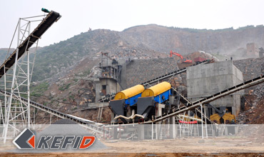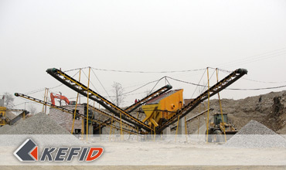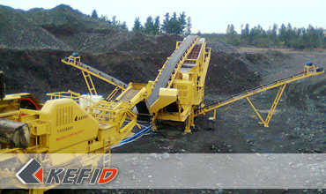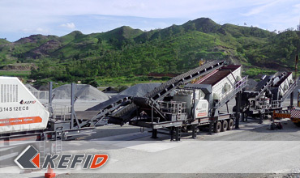

Features of Stone Crushing Plant
This Stone Crushing Plant is of high automation, adjustable in size of end product, and has a high crushing ratio, high capacity, even and good grain shape. This line is suitable for road and bridge subjects of various sizes. Meanwhile, stone crushing and screening equipment developed by our company has reasonable combination of crushing equipments of different grade, and a perfect distribution of space cross. Thus, it has the features of small place-taking and high output of investment.
Allocation of equipments is determined according to customers’ requirements in stone specification, capacity and usage of stones. We can offer you perfect service pre-in-after sales. We can allocate proceeding according to customers’ working site, so as to make a reasonable and economical production line.

Application of Stone Crushing Plant
Stone Crushing Plant is quite suitable for crushing with hardness below medium hardness, such as limestone, limestone, shale, granite and so on. It’s widely used in hydroelectric, construction material, high way, city construction and other industries.

Plans of Stone Crushing Plant
1. Vibrating feeder + jaw crusher + Multi-cylinder Hydraulic Cone crusher+ reshaping machine (VSI Crusher) + vibrating screen
Main characters of this plan is that it adopts advanced multi-cylinder hydraulic cone crusher. This makes fine products to take a bigger proportion. 80% of the finals can be smaller than the size of discharge opening. It will obviously increase processing capacity and decrease general energy cost. Add reshaping equipment as the secondary crusher can assure the quality and shape of the final products on one hand; on the other hand , some sands can be chose for other usage.
The efficiency of the whole line is very high. Working life of easy-worn parts is long. Continuous operating time of the equipment is longer, and it is easy to maintain. The general economic profits are higher than the traditional plants.
2. Vibrating feeder + Jaw crusher + Symons cone crusher + Reshaping machine + vibrating screen
This plan adopts high efficiency CS cone crusher and it makes fine products to take a bigger proportion. It reduces secondary crushing and gets much more final products. The reshaping equipment as the secondary crusher can assure the quality and the shape of the final products on one hand; on the other hand , some sands can be chosen for other usage.
Working life of easy-worn parts of the whole production line is long. It has the feature of easy maintenance, less investment at one time, smaller operating cost and higher general economic profits.
3. Vibrating feeder + Jaw Crusher + HP single-cylinder cone crusher + vibrating screen
This plan is mainly suitable for processing hard material, like granite. Since the secondary crusher is hydraulic equipment, it has the feature of easy maintenance, less investment at one time, simple flow process, easy to operate. It is widely used in the industry which produces mixed materials or there is lower requirement of shape of the materials. This line has the features of combining with few types of equipments, easy maintenance, and indiscrete structure. It is suitable for any scale of investment due to smaller floor space requirement.
4. Vibrating feeder + Jaw crusher + Symons cone crusher + vibrating screen
This plan is suitable for processing hard materials, like granite. Comparing with the same scale plans, the obvious feature of this plan is smaller investment at one time, simple flow process, easy operating and maintenance. The easy-worn parts using is fewer. Its economic profits are higher while manufacturing cost is lower.
5. Vibrating feeder + Jaw crusher + Impact crusher + vibrating screen
This plan is mainly suitable for processing soft materials, like limestone. Comparing with the same scale plans, the obvious feature of this plan is smaller investment at one time, simple flow process, easy operating and maintenance. This line can produce good final products with nice shape stones. It is widely used as a traditional economic plan.

Our Senior Manager
  Kevin |   Johnny |   Peter
Contact Us
Shanghai | Zhengzhou
Tel: +86-21-58385016  Fax: +86-21-58377628  E-mail: sales@kefidinc.com | Tel: + 86-371-67999255  Fax: +86-371-67998980  E-mail: david@kefidinc.com

Products | Gallery
Mobile Crushing Plant  Crawler Mobile Crusher  Mobile Jaw Crusher  Mobile Impact Crusher  Mobile Cone Crusher  Mobile VSI Crusher  Stationary Crushing Plant  Jaw Crusher  Impact Crusher  Cone Crusher  VSI Crusher  Aggregate Production Line  Stone Crushing Plant  Sand Making Plant  Grinding Mill  Vertical Mill  MTW Series Trapezoid Mill  European Hammer Mill  Micro Powder Mill  Trapezium Mill  High Pressure Mill  Raymond Mill  Ball Mill  Screening & Washing  Vibrating Screen  Screw Sand Washing Machine  Wheel Sand Washing Machine  Feeding & Conveying  Vibrating feeder  Belt Conveyor | Crushing  Mobile Crushing Plant  Stationary Crushing Plant  Jaw Crusher  Impact Crusher  Cone Crusher  VSI Crusher  Aggregate Production Line  Grinding Mill  Vertical Grinding Mill  MTW Series Trapezoid Mill  Micro Powder Mill  Trapezium Mill  High Pressure Mill  Raymond Mill  Ball Mill  European Hammer Mill  Screening & Washing  Vibrating Screen  Sand Washing Machine  Feeding & Conveying  Vibrating Feeder  Belt Conveyor  Delivery of Products  Technology  Workshop  Clients Visit and Exhibiton  Corporate Culture

