Spring Cone Crusher
Link: Gallery Get this product price
Spring cone crusher is suitable to crush various kinds of ores and rocks of medium or above medium hardness. The type of crushing chamber depends on the size of feeding and fineness of the crushed product. The standard type is applied to medium crushing, the medium type is applied to medium or fine crushing and the short head type is applied to fine crushing.
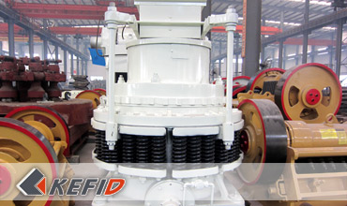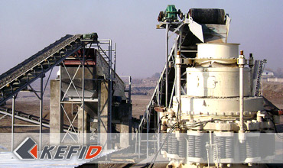

Application of Spring Cone Crusher
Spring cone crusher is the first of a cone crusher, an researched and developed hydraulic crusher of advanced high-power, large crushing ratio, high productivity. The machine was developed with the digestion and absorption of the 80 countries with various types of international advanced level on the basis of cone crusher. It is obviously different in design from traditional cone crusher, and focus on the main advantages of various types of cone crusher known to the date, which is suitable for fine crushing and super fine crushing hard rock, ore, slag refractory. Cone crusher can be widely used in metallurgy industry, construction industry, road building, chemical industry and the phosphate industry and suitable for crushing hard and medium hard ore and rock, such as iron ore copper ore, limestone, quartz, granite, basalt and so on.

Technical Data of Spring Cone Crusher
Type |  | Max. input (mm) | Adjusting range  of output (mm) | Capacity (t/h) | Motor power  (kW) | weight (t) | Overall dimensions  (L×W×H)(mm)
PYB | 900 | 115 | 15-50 | 50-90 | 55 | 10.2 | 3050×1640×2350
PYZ | 900 | 60 | 5-20 | 20-65 | 55 | 10.2 | 3050×1640×2350
PYD | 900 | 40 | 3-13 | 15-50 | 55 | 10.3 | 3050×1640×2350
PYB | 1200 | 145 | 20-50 | 110-200 | 110 | 24.7 | 4152×2300×2980
PYZ | 1200 | 100 | 8-26 | 50-150 | 110 | 25 | 4152×2300×2980
PYD | 1200 | 50 | 3-15 | 18-105 | 110 | 25.6 | 4152×2300×2980
PYB | 1750 | 215 | 25-60 | 280-480 | 160 | 50.3 | 4870×3800×4192
PYZ | 1750 | 185 | 10-30 | 115-320 | 160 | 50.3 | 4870×3800×4192
PYD | 1750 | 85 | 5-15 | 75-230 | 160 | 50.4 | 4870×3800×4192
PYB | 2200 | 300 | 30-60 | 590-1000 | 260-280 | 80 | 7705×3430×4852
PYZ | 2200 | 230 | 10-30 | 200-580 | 260-280 | 80 | 7705×3430×4852
PYD | 2200 | 100 | 5-15 | 120-340 | 260-280 | 81.4 | 7705×3430×4852

Note: Any change of HP Cone Crusher technical data shall not be advised additionally.

Our Senior Manager
  Kevin |   Johnny |   Peter
Contact Us
Shanghai | Zhengzhou
Tel: +86-21-58385016  Fax: +86-21-58377628  E-mail: sales@kefidinc.com | Tel: + 86-371-67999255  Fax: +86-371-67998980  E-mail: david@kefidinc.com

Products | Gallery
Mobile Crushing Plant  Crawler Mobile Crusher  Mobile Jaw Crusher  Mobile Impact Crusher  Mobile Cone Crusher  Mobile VSI Crusher  Stationary Crushing Plant  Jaw Crusher  Impact Crusher  Cone Crusher  VSI Crusher  Aggregate Production Line  Stone Crushing Plant  Sand Making Plant  Grinding Mill  Vertical Mill  MTW Series Trapezoid Mill  European Hammer Mill  Micro Powder Mill  Trapezium Mill  High Pressure Mill  Raymond Mill  Ball Mill  Screening & Washing  Vibrating Screen  Screw Sand Washing Machine  Wheel Sand Washing Machine  Feeding & Conveying  Vibrating feeder  Belt Conveyor | Crushing  Mobile Crushing Plant  Stationary Crushing Plant  Jaw Crusher  Impact Crusher  Cone Crusher  VSI Crusher  Aggregate Production Line  Grinding Mill  Vertical Grinding Mill  MTW Series Trapezoid Mill  Micro Powder Mill  Trapezium Mill  High Pressure Mill  Raymond Mill  Ball Mill  European Hammer Mill  Screening & Washing  Vibrating Screen  Sand Washing Machine  Feeding & Conveying  Vibrating Feeder  Belt Conveyor  Delivery of Products  Technology  Workshop  Clients Visit and Exhibiton  Corporate Culture

