Sand Making Plant
Link: Gallery Get this product price
The full set Sand Making Plant will offer you with comprehensive technological support, the production line is generally composed of vibrating feeder, jaw crusher, vertical impact crusher(sand-making machine), vibration screen, sand washing machine, belt conveyor, assemble electricity control; The internationally advanced VSI crusher researched and developed by our company matched with the other series of products forms an internationally leading position in this industry.
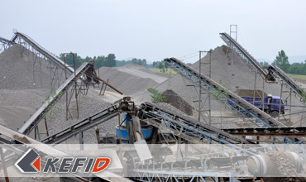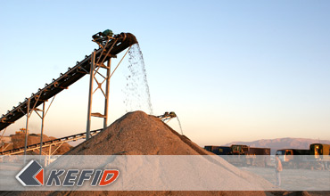

Features of Sand Making Plant
The joint equipments of crushers and screens developed by KEFID has the features of small space taking and high investment-profit ratio, because of graded equipments mach and accurate space cross distribution, which can guarantee a good material pass in the whole process. Meanwhile, it's highly automatic, it's modulus is adjustable, it's running cost is low, it's ratio of success is high, it's energy saving, it has less pollution, easy to maintenance, it performs well, it's simple to operate and is quite efficient.

Application of Sand Making Plant
The full set of sand making equipment can be used in hard limestone, granite, basalt, river gravel, stone chips, various rock and ore tailings to make machine made sand, which is widely used in hydroelectric, construction materials, highway, city construction and other industries.

Plans of Sand Making Plant
1. Vibrating feeder + jaw crusher + cone crusher + Deep Rotor VSI Crusher + vibrating screen
High crushing ratio of cone crusher and small crushed size ensures feeding size and crushing efficiency of VSI impact crusher. Deep Rotor VSI Crusher is the third generation of manufactured sand equipment and has many important improvements on vital working parts, like spindly impact plates which has a much longer life time. Advanced hydraulic set used makes maintenance easier and it is suitable for large scale manufactured sand production line of high automation degree.
This manufactured sand production line has a long life time for spare parts, long consecutive working time and easy maintenance. All this increases the overall economic benefits greatly.
2. Vibrating feeder + primary jaw crusher + secondary jaw crusher + Deep Rotor VSI Crusher + vibrating screen
In this design secondary jaw crusher is used to replace cone crusher. It can decrease once and for all cost of investment and is suitable for medium and small size manufactured sand production line.
The complete sand production line has a long life time for spare parts, long consecutive working time and easy maintenance. It has a low once and for all investment cost and good overall economic benefits
3. Vibrating feeder + jaw crusher + cone crusher + VSI Crusher + vibrating screen
In this design VSI crusher is used to replace Deep Rotor VSI Crusher which is used in the first design. VSI crusher has a lower investment cost compared with Deep Rotor VSI Crusher, it also has hydraulic setting and is easy to maintain and change spare parts.
4. Vibrating feeder + primary jaw crusher + secondary jaw crusher + P series VSI crusher + vibrating screen
This is the most economic design. The disadvantage is that P series VSI crusher has no hydraulic system, its maintenance and usage is also relatively complicated. Outstanding advantage of this design is that it has a much lower investment cost.

Our Senior Manager
  Kevin |   Johnny |   Peter
Contact Us
Shanghai | Zhengzhou
Tel: +86-21-58385016  Fax: +86-21-58377628  E-mail: sales@kefidinc.com | Tel: + 86-371-67999255  Fax: +86-371-67998980  E-mail: david@kefidinc.com

Products | Gallery
Mobile Crushing Plant  Crawler Mobile Crusher  Mobile Jaw Crusher  Mobile Impact Crusher  Mobile Cone Crusher  Mobile VSI Crusher  Stationary Crushing Plant  Jaw Crusher  Impact Crusher  Cone Crusher  VSI Crusher  Aggregate Production Line  Stone Crushing Plant  Sand Making Plant  Grinding Mill  Vertical Mill  MTW Series Trapezoid Mill  European Hammer Mill  Micro Powder Mill  Trapezium Mill  High Pressure Mill  Raymond Mill  Ball Mill  Screening & Washing  Vibrating Screen  Screw Sand Washing Machine  Wheel Sand Washing Machine  Feeding & Conveying  Vibrating feeder  Belt Conveyor | Crushing  Mobile Crushing Plant  Stationary Crushing Plant  Jaw Crusher  Impact Crusher  Cone Crusher  VSI Crusher  Aggregate Production Line  Grinding Mill  Vertical Grinding Mill  MTW Series Trapezoid Mill  Micro Powder Mill  Trapezium Mill  High Pressure Mill  Raymond Mill  Ball Mill  European Hammer Mill  Screening & Washing  Vibrating Screen  Sand Washing Machine  Feeding & Conveying  Vibrating Feeder  Belt Conveyor  Delivery of Products  Technology  Workshop  Clients Visit and Exhibiton  Corporate Culture

