Primary Impact Crusher
Link: Gallery Get this product price
Primary impact crusher is KEFID's new product absorbing international latest technology. As the crusher's "heart", rotor is the most important part. PFP impact crushers are generally used as a primary crushers for crushing quarry rock, which are designed for crushing low abrasive and medium hard materials.
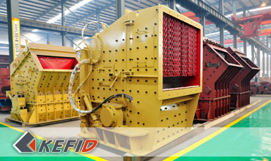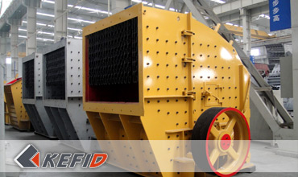

Features of Primary Impact Crusher
1. Adopt world-level manufacturing technology, and excellent production materials.
2. Heavy-duty design of the rotor, and rigorous tests to ensure the quality of the rotor.
3. Adopts integrated steel bearing structure.
4. The unique hammer plate fixtures, making the board more reliable.
5. Improved adjustment device, reducing downtime and maintenance time.
6. The choice of larger bearing specification, making carrying capacity higher.
7. Analysis of the rotor to ensure stable and reliable.

Application of Primary Impact Crusher
Primary impact crusher uses high wear-resistant materials, and the best crushing chamber, which makes extraordinary performance and is very suitable to crush various kinds of soft, medium hard ore, rough pieces of material, widely used in metallurgy, mining, cement, chemicals, refractory and ceramics, highway construction, water conservancy projects, building stone project and so on.

Working Principle of Primary Impact Crusher
The materials fed to the crusher trough its large feeding opening are crushed in two stages while impacted by the rotor's hammers to the adjustable primary and secondary impact plates. The materials will not pass to the secondary impact plate until being crushed and reduced to the size which the primary impact plate is adjusted to and will not pass to discharging chute until being crushed and reduced to the size which the secondary impact plate is adjusted to. By this adjustable impact plates the maximum size of output material can be controlled.

Technical Data of Primary Impact Crusher
P model | Spec. | Feeding  size (mm) | Max. feeding  size (mm) | Capacity (t/h) | Power (kW) | Weight (t)
PFP 1210 | Ф1150X960 | 1100X1030 | 400 | 90-160 | 90-110 | 17.0
PFP 1214 | Ф1150X1400 | 1100X1430 | 500 | 130-200 | 132-160 | 22.0
PFP 1315 | Ф1300X1500 | 1200X1530 | 600 | 180-320 | 160-200 | 29.0
PFP 1318 | Ф1300X1800 | 1200X1830 | 700 | 240-400 | 200-250 | 34.0
Note: Any change of Primary Impact Crusher technical data shall not be advised additionally.

Our Senior Manager
  Kevin |   Johnny |   Peter
Contact Us
Shanghai | Zhengzhou
Tel: +86-21-58385016  Fax: +86-21-58377628  E-mail: sales@kefidinc.com | Tel: + 86-371-67999255  Fax: +86-371-67998980  E-mail: david@kefidinc.com

Products | Gallery
Mobile Crushing Plant  Crawler Mobile Crusher  Mobile Jaw Crusher  Mobile Impact Crusher  Mobile Cone Crusher  Mobile VSI Crusher  Stationary Crushing Plant  Jaw Crusher  Impact Crusher  Cone Crusher  VSI Crusher  Aggregate Production Line  Stone Crushing Plant  Sand Making Plant  Grinding Mill  Vertical Mill  MTW Series Trapezoid Mill  European Hammer Mill  Micro Powder Mill  Trapezium Mill  High Pressure Mill  Raymond Mill  Ball Mill  Screening & Washing  Vibrating Screen  Screw Sand Washing Machine  Wheel Sand Washing Machine  Feeding & Conveying  Vibrating feeder  Belt Conveyor | Crushing  Mobile Crushing Plant  Stationary Crushing Plant  Jaw Crusher  Impact Crusher  Cone Crusher  VSI Crusher  Aggregate Production Line  Grinding Mill  Vertical Grinding Mill  MTW Series Trapezoid Mill  Micro Powder Mill  Trapezium Mill  High Pressure Mill  Raymond Mill  Ball Mill  European Hammer Mill  Screening & Washing  Vibrating Screen  Sand Washing Machine  Feeding & Conveying  Vibrating Feeder  Belt Conveyor  Delivery of Products  Technology  Workshop  Clients Visit and Exhibiton  Corporate Culture

