PF Impact Crusher
Link: Gallery Get this product price
PF Series Impact Crusher uses the latest manufacturing technology, say, unique structural design. PF Impact Crusher's finished product is cube size, no tension and cracks, and its grain shape is good, which can break particle sizes less than 500mm, compressive strength is no more than 350MPa medium, fine materials (granite, limestone, concrete, etc.)
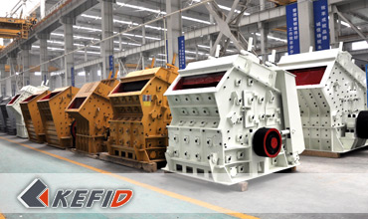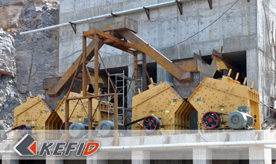

Features of PF Impact Crusher
1. Large feeding size, high crushing chamber to meet the higher material hardness, large block, and less product powder;
2. Easy adjustments of hammer and impacting plate.
3. Compact structure, machine rigidity, the rotor has large impacting energy;
4. High chrome hammer, impact resistance, abrasion resistance, large impacting force;
5. A new type rotor to increase the impact force;
6. High productivity, low energy consumption, high overall efficiency.
7. Simple structure, easy maintenance and reliable.

Application of PF Impact Crusher
The impact crusher is widely used in ore crushing, railway, highway, energy, cement, chemicals, construction and other industries on a variety of medium hardness material, it can crush limestone, cooked material, slag, coke and coal. The particle size, specification diversification can be adjusted.

Working Principle of PF Impact Crusher
PF impact crushers are generally used as primary crushers for crushing quarry rock, which are designed for crushing low abrasive and medium hard materials. The materials fed to the crusher through its large feeding opening are crushed in two stages : while impacted by the rotor's hammers to the primary and secondary impact plates. The materials will not pass to the secondary impact plate until being crushed and reduced to the required size. By adjusting the impact plates the maximum size of output material can be controlled.

Technical Data of PF Impact Crusher
Model | Size of rotor (mm) | Feed opening  (mm) | Max. feed  size (mm) | Capacity (t/h) | Power of  Motor (kW) | Weight (t)
PF1010 | Φ1000×1050 | 400×1080 | 350 | 50-80 | 75 | 12.5
PF1210 | Φ1250×1050 | 400×1080 | 350 | 70-130 | 110 | 16.5
PF1214 | Φ1250×1400 | 400×1430 | 350 | 90-180 | 132 | 19
PF1315 | Φ1320×1500 | 860×1520 | 500 | 120-250 | 200 | 24
PF1320 | Φ1320×2000 | 860×2030 | 500 | 160-350 | 260 | 27
Note: Any change of PF Impact Crusher technical data shall not be advised additionally.

Our Senior Manager
  Kevin |   Johnny |   Peter
Contact Us
Shanghai | Zhengzhou
Tel: +86-21-58385016  Fax: +86-21-58377628  E-mail: sales@kefidinc.com | Tel: + 86-371-67999255  Fax: +86-371-67998980  E-mail: david@kefidinc.com

Products | Gallery
Mobile Crushing Plant  Crawler Mobile Crusher  Mobile Jaw Crusher  Mobile Impact Crusher  Mobile Cone Crusher  Mobile VSI Crusher  Stationary Crushing Plant  Jaw Crusher  Impact Crusher  Cone Crusher  VSI Crusher  Aggregate Production Line  Stone Crushing Plant  Sand Making Plant  Grinding Mill  Vertical Mill  MTW Series Trapezoid Mill  European Hammer Mill  Micro Powder Mill  Trapezium Mill  High Pressure Mill  Raymond Mill  Ball Mill  Screening & Washing  Vibrating Screen  Screw Sand Washing Machine  Wheel Sand Washing Machine  Feeding & Conveying  Vibrating feeder  Belt Conveyor | Crushing  Mobile Crushing Plant  Stationary Crushing Plant  Jaw Crusher  Impact Crusher  Cone Crusher  VSI Crusher  Aggregate Production Line  Grinding Mill  Vertical Grinding Mill  MTW Series Trapezoid Mill  Micro Powder Mill  Trapezium Mill  High Pressure Mill  Raymond Mill  Ball Mill  European Hammer Mill  Screening & Washing  Vibrating Screen  Sand Washing Machine  Feeding & Conveying  Vibrating Feeder  Belt Conveyor  Delivery of Products  Technology  Workshop  Clients Visit and Exhibiton  Corporate Culture

