PE Jaw Crusher
Link: Gallery Get this product price
As the domestic leading manufacturer in crushing and screening area, our products have reached world-level advanced standard. PE Jaw Crusher, as the first choice of primary crushing, can be divided into coarse crushing and fine crushing, the feeding size is 125mm~750mm.
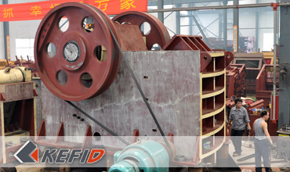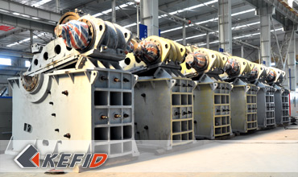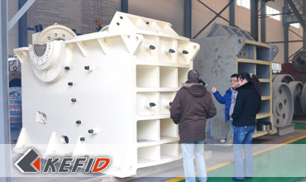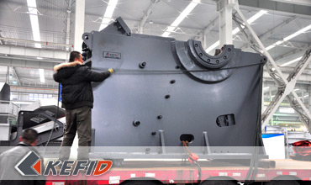

Features of PE Jaw Crusher
High crushing ratio, Even final size, Simple structure, Reliable working condition, Easy maintenance, Low operating cost.

Application of PE Jaw Crusher
PE Jaw Crusher is mainly used in medium size crushing of rocks and bulk material, whose compressive strength is below 320Mpa. Jaw Crusher is widely used in mine, metallurgy, the building, road and railroad construction, hydraulic construction, chemical industry, fire-proofing material and ceramics.

Working Principle of PE Jaw Crusher
The plant is composed of main frame, eccentric shaft, flying wheel, toggle plate, jaw plate, tension rod, fixed jaw, movable jaw, and toggle plate can secure the whole body.
The motor transmits power through belt, and drives the moving jaw to do periodic motion towards the fixed jaw by the eccentric shaft. The angle between toggle plate and moving jaw plate increases when moving jaw moves. So the moving jaw moves towards the fixed jaw. The stuff will be crushed during this process. The angle between toggle plate and moving jaw decreases when moving jaw moves down, the moving jaw leaves fixed jaw by pulling rod and spring, the crushed stuff will be discharged from the outlet.

Technical Data of PE Jaw Crusher
Model | Max. Feeding  Size (mm) | Discharge  Size (mm) | Capacity (t/h) | Motor  Power (kw) | Overall  Dimensions (mm) | Weight (t)
PE400×600 | 350 | 40-100 | 15-60 | 30 | 1700×1732×1653 | 6.5
PE500×750 | 425 | 50-100 | 50-100 | 55 | 2035×1921×2000 | 10.3
PE600×900 | 480 | 65-160 | 60-168 | 75 | 2290×2206×2370 | 16.5
PE750×1060 | 630 | 80-140 | 100-250 | 110 | 2620×2302×3110 | 29
PE900×1200 | 750 | 95-165 | 160-380 | 130 | 3789×2826×3025 | 54.5
PE1000×1200 | 850 | 195-265 | 315-550 | 130 | 3335×3182×3025 | 57
PE1200×1500 | 1020 | 150-300 | 400-800 | 160-220 | 4200×3750×3820 | 100.9
Note: Any change of PE Jaw Crusher technical data shall not be advised additionally.

Our Senior Manager
  Kevin |   Johnny |   Peter
Contact Us
Shanghai | Zhengzhou
Tel: +86-21-58385016  Fax: +86-21-58377628  E-mail: sales@kefidinc.com | Tel: + 86-371-67999255  Fax: +86-371-67998980  E-mail: david@kefidinc.com
Products | Gallery
Mobile Crushing Plant  Crawler Mobile Crusher  Mobile Jaw Crusher  Mobile Impact Crusher  Mobile Cone Crusher  Mobile VSI Crusher  Stationary Crushing Plant  Jaw Crusher  Impact Crusher  Cone Crusher  VSI Crusher  Aggregate Production Line  Stone Crushing Plant  Sand Making Plant  Grinding Mill  Vertical Mill  MTW Series Trapezoid Mill  European Hammer Mill  Micro Powder Mill  Trapezium Mill  High Pressure Mill  Raymond Mill  Ball Mill  Screening & Washing  Vibrating Screen  Screw Sand Washing Machine  Wheel Sand Washing Machine  Feeding & Conveying  Vibrating feeder  Belt Conveyor | Crushing  Mobile Crushing Plant  Stationary Crushing Plant  Jaw Crusher  Impact Crusher  Cone Crusher  VSI Crusher  Aggregate Production Line  Grinding Mill  Vertical Grinding Mill  MTW Series Trapezoid Mill  Micro Powder Mill  Trapezium Mill  High Pressure Mill  Raymond Mill  Ball Mill  European Hammer Mill  Screening & Washing  Vibrating Screen  Sand Washing Machine  Feeding & Conveying  Vibrating Feeder  Belt Conveyor  Delivery of Products  Technology  Workshop  Clients Visit and Exhibiton  Corporate Culture

