Mobile Impact Crusher
Link: Gallery Get this product price
The mobile impact crusher is a star product of KEFID ,which is equipped by the unit configuration, uses the latest manufacturing technology, adopts the high-quality chrome blow bar and wear-resisting counterattack linings, and has great crushing ratio, Because of its own advantage of good particle shape, The mobile impact crusher plant is especially convenient for operation in a small working site, to process and crush the construction waste.
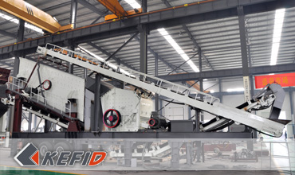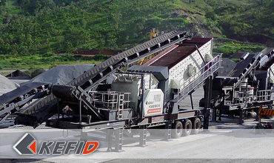

Application of Mobile Impact Crusher
The mobile impact crusher is widely used in various fields, say, metallurgy, chemical, construction material, hydroelectric fields to process materials that need to be moved frequently especially in processing the liquid stones for highway, railway, and hydroelectric subjects. Customers can equip different configuration according to different processing materials, scale and requirements.
Characteristics: large capacity, medium-size crushing, high efficient, economic, strong adaptability, self-contained conveyor.

Technical Data of Mobile Impact Crusher
Model | Y3S184F1210 | Y3S186F1214 | Y3S216F1315 | Y3S184FW1210 | Y3S186FW1214 | Y3S216FW1315
Transportation Length (mm) | 14200 | 16000 | 16000 | 14000 | 16000 | 16000
Transportation Width (mm) | 3100 | 3100 | 3200 | 3100 | 3100 | 3200
Transportation Height (mm) | 4400 | 4400 | 4500 | 4400 | 4400 | 4500
Maximum Length (mm) | 14600 | 16400 | 16400 | 14400 | 16400 | 16400
Maximum width (mm) | 3400 | 3400 | 3500 | 3400 | 3400 | 3500
Maximum Height (mm) | 5100 | 5500 | 4700 | 4700 | 4700 | 4700
Weight (T) | 35 | 44.5 | 47.5 | 34.5 | 41.5 | 48.5
Tire Configuration | Dualaxial | Triaxial | Triaxial | Dualaxial | Triaxial | Triaxial
Impact crusher | PF1210 | PF1214 | PF1315 | PFS1210 | PFS1214 | PFS1315
Feed opening size | 400*1080 | 400*1430 | 860*1520 | 570X990 | 570X1430 | 625X1530
The maximum Feeding size (mm) | 350 | 350 | 500 | 250 | 250 | 300
Capacity (T/h) | 70-300 | 90-400 | 120-450 | 90-300 | 120-360 | 150-440
Belt conveyor | B650X7M | B800X8M | B1000X8M | B650X7M | B800X8M | B1000X8M
Vibrating Screen | 3YZS1848 | 3YZS1860 | 3YZS2160 | 3YZS1848 | 3YZS1860 | 3YZS2160
Note: Any change of Mobile Impact Crusher technical data shall not be advised additionally.

Our Senior Manager
  Kevin |   Johnny |   Peter
Contact Us
Shanghai | Zhengzhou
Tel: +86-21-58385016  Fax: +86-21-58377628  E-mail: sales@kefidinc.com | Tel: + 86-371-67999255  Fax: +86-371-67998980  E-mail: david@kefidinc.com

Products | Gallery
Mobile Crushing Plant  Crawler Mobile Crusher  Mobile Jaw Crusher  Mobile Impact Crusher  Mobile Cone Crusher  Mobile VSI Crusher  Stationary Crushing Plant  Jaw Crusher  Impact Crusher  Cone Crusher  VSI Crusher  Aggregate Production Line  Stone Crushing Plant  Sand Making Plant  Grinding Mill  Vertical Mill  MTW Series Trapezoid Mill  European Hammer Mill  Micro Powder Mill  Trapezium Mill  High Pressure Mill  Raymond Mill  Ball Mill  Screening & Washing  Vibrating Screen  Screw Sand Washing Machine  Wheel Sand Washing Machine  Feeding & Conveying  Vibrating feeder  Belt Conveyor | Crushing  Mobile Crushing Plant  Stationary Crushing Plant  Jaw Crusher  Impact Crusher  Cone Crusher  VSI Crusher  Aggregate Production Line  Grinding Mill  Vertical Grinding Mill  MTW Series Trapezoid Mill  Micro Powder Mill  Trapezium Mill  High Pressure Mill  Raymond Mill  Ball Mill  European Hammer Mill  Screening & Washing  Vibrating Screen  Sand Washing Machine  Feeding & Conveying  Vibrating Feeder  Belt Conveyor  Delivery of Products  Technology  Workshop  Clients Visit and Exhibiton  Corporate Culture

