Mobile Cone Crusher
Link: Gallery Get this product price
The new launched mobile cone crusher by KEFID is an up-to –minute rock crushing equipments, which is widely used in construction waste disposal and crush, highway, railway construction, hydroelectric plants and other large projects. Integrated installation and coordinated work of the whole unit fully display the advantages of convenience and flexibility.
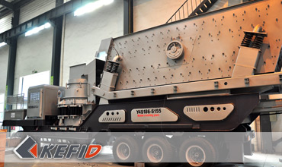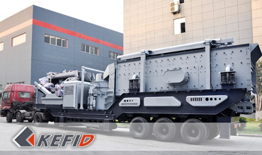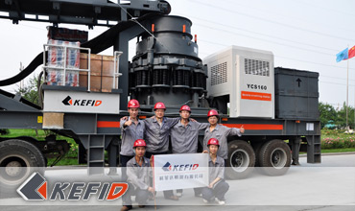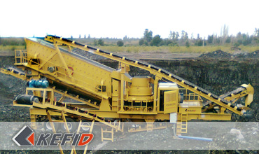

Features of Mobile Cone Crusher
Mobile cone crushing plant can be manufactured according to customers’ requirements, in strict accordance with the actual situation. It is of high capacity, high efficiency, medium and fine crushing and strong adaptability etc.
Mobile cone crushing plant mainly consists of high efficient cone crusher, high performance screener, belt conveyor, motor and electric control box etc.

Application of Mobile Cone Crusher
Mobile cone crusher plant is mainly used in fine crushing area. According to different stone and different purpose of products, mobile cone crusher can replace impact crusher in aggregates production circuit to produce sand, stone products harder and finer. Configuration of the cone crusher can be adjusted according to actual needs , adopting different crushing chamber type or expanding the scope and areas of cone crusher.

Technical Data of Mobile Cone Crusher
Model Technical data | Y3S1848CS75 | Y3S1860CS160 | Y3S216HP220 | Y3S1860HP220
Transportation Length (mm) | 13500 | 15200 | 15200 | 15200
Transportation Width (mm) | 2830 | 2830 | 3000 | 2830
Transportation Height (mm) | 4350 | 4350 | 4350 | 4350
Maximum Length (mm) | 13700 | 15245 | 15245 | 15245
Maximum Width (mm) | 3150 | 3150 | 3500 | 3898
Maximum Height (mm) | 5700 | 6400 | 6400 | 6394
Weight (T) | 38 | 46 | 43.5 | 42
Tire Configuration | Dualaxial | Triaxial | Triaxial | Triaxial
Cone crusher | CS75 | HP160 | HP220 | HP220
The maximum  Feeding size (mm) | 102 | C-150  F-76 | C-225  F-86 | C-225  F-86
Discharge  opening size (mm) | 9-38 | C-13  F-6 | C-13  F-6 | C-13  F-6
Capacity (T/h) | 45-165 | C120-240  F55-180 | C150-430  F90-260 | C150-430  F90-260
Belt conveyor | B800X7M | B800X8M | B1000X8M | B800X8M
Vibrating Screen | 3YZS1848 | 3YZS1860 | 3YZS2160 | 3YZS1860
Note: Any change of Mobile Cone Crusher technical data shall not be advised additionally.

Our Senior Manager
  Kevin |   Johnny |   Peter
Contact Us
Shanghai | Zhengzhou
Tel: +86-21-58385016  Fax: +86-21-58377628  E-mail: sales@kefidinc.com | Tel: + 86-371-67999255  Fax: +86-371-67998980  E-mail: david@kefidinc.com
Products | Gallery
Mobile Crushing Plant  Crawler Mobile Crusher  Mobile Jaw Crusher  Mobile Impact Crusher  Mobile Cone Crusher  Mobile VSI Crusher  Stationary Crushing Plant  Jaw Crusher  Impact Crusher  Cone Crusher  VSI Crusher  Aggregate Production Line  Stone Crushing Plant  Sand Making Plant  Grinding Mill  Vertical Mill  MTW Series Trapezoid Mill  European Hammer Mill  Micro Powder Mill  Trapezium Mill  High Pressure Mill  Raymond Mill  Ball Mill  Screening & Washing  Vibrating Screen  Screw Sand Washing Machine  Wheel Sand Washing Machine  Feeding & Conveying  Vibrating feeder  Belt Conveyor | Crushing  Mobile Crushing Plant  Stationary Crushing Plant  Jaw Crusher  Impact Crusher  Cone Crusher  VSI Crusher  Aggregate Production Line  Grinding Mill  Vertical Grinding Mill  MTW Series Trapezoid Mill  Micro Powder Mill  Trapezium Mill  High Pressure Mill  Raymond Mill  Ball Mill  European Hammer Mill  Screening & Washing  Vibrating Screen  Sand Washing Machine  Feeding & Conveying  Vibrating Feeder  Belt Conveyor  Delivery of Products  Technology  Workshop  Clients Visit and Exhibiton  Corporate Culture

