Hydraulic Impact Crusher
Link: Gallery Get this product price
Hydraulic impact crusher is widely used in building materials, highways, railways, cement, mining and chemical industries, crushing soft material, medium hardness minerals. Maximum Feed size range (the maximum anti-crushing compressive strength 300Mpa, humidity should be less than 8-10%) should be no more than 700MM. The improved hydraulic device adjustment makes operation more convenient. Three-chamber design assures extraordinary performance.
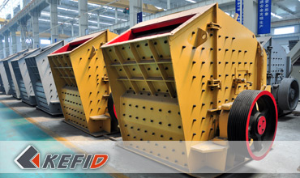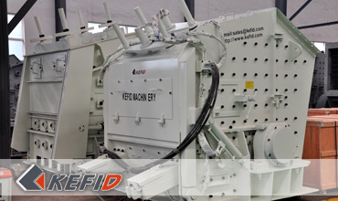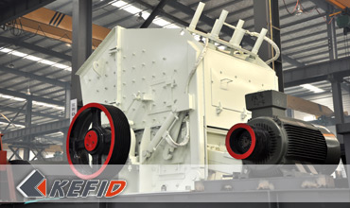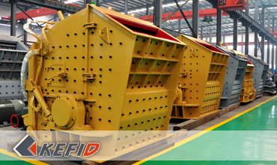

Technical Data of Hydraulic Impact Crusher
P model | Spec. | Feeding  size (mm) | Max. feeding  size (mm) | Capacity (t/h) | Power (kW) | Weight (t)
PFS1210 | Ф1150X960 | 570X990 | 250 | 70-120 | 90-110 | 15.0
PFS1214 | Ф1150X1400 | 570X1430 | 250 | 90-170 | 132-160 | 19.0
PFS1315 | Ф1300X1500 | 625X1530 | 300 | 180-270 | 160-200 | 25.0
PFS1318 | Ф1300X1800 | 625X1830 | 300 | 220-300 | 200-250 | 30.0
Note: Any change of Hydraulic Impact Crusher technical data shall not be advised additionally.

Our Senior Manager
  Kevin |   Johnny |   Peter
Contact Us
Shanghai | Zhengzhou
Tel: +86-21-58385016  Fax: +86-21-58377628  E-mail: sales@kefidinc.com | Tel: + 86-371-67999255  Fax: +86-371-67998980  E-mail: david@kefidinc.com

Products | Gallery
Mobile Crushing Plant  Crawler Mobile Crusher  Mobile Jaw Crusher  Mobile Impact Crusher  Mobile Cone Crusher  Mobile VSI Crusher  Stationary Crushing Plant  Jaw Crusher  Impact Crusher  Cone Crusher  VSI Crusher  Aggregate Production Line  Stone Crushing Plant  Sand Making Plant  Grinding Mill  Vertical Mill  MTW Series Trapezoid Mill  European Hammer Mill  Micro Powder Mill  Trapezium Mill  High Pressure Mill  Raymond Mill  Ball Mill  Screening & Washing  Vibrating Screen  Screw Sand Washing Machine  Wheel Sand Washing Machine  Feeding & Conveying  Vibrating feeder  Belt Conveyor | Crushing  Mobile Crushing Plant  Stationary Crushing Plant  Jaw Crusher  Impact Crusher  Cone Crusher  VSI Crusher  Aggregate Production Line  Grinding Mill  Vertical Grinding Mill  MTW Series Trapezoid Mill  Micro Powder Mill  Trapezium Mill  High Pressure Mill  Raymond Mill  Ball Mill  European Hammer Mill  Screening & Washing  Vibrating Screen  Sand Washing Machine  Feeding & Conveying  Vibrating Feeder  Belt Conveyor  Delivery of Products  Technology  Workshop  Clients Visit and Exhibiton  Corporate Culture

