High Pressure Mill
Link: Gallery Get this product price
High pressure mill is mainly suitable for process various non-flammable, non-explosive ore materials with mohs hardness below 9.3 and humidity below 6%, such as metallurgy, construction materials, chemicals, ores, highway construction, hydroelectric subjects and so on. Fineness of final products should range from 0.613mm to 0.033mm.
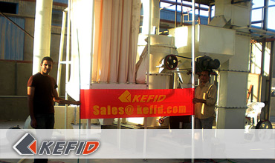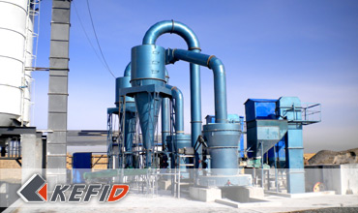

Features of High Pressure Mill
1. Unique design. Inside the cavity of the main engine, a compression device of 1500kg-2000kg has been installed on the plum frame. Under same power, production can be 10%-30% higher, grinding power generated by grinding device increased by 800-1500kgf, the most fine powder product can be 1000 mohs.
2. Various materials are adaptable, and all materials with mohs hardness below 9.3 are qualified.
3. Dust removing effect can fully match the national standard.
4. Roller device is of high-quality and high-efficient processing, multiple and multi-grade seal can guarantee perfect seal effect.
5. Changing cycle of rollers and grinding ring is long, which is able to avoid the disadvantage of short changing cycle of wearable parts of the centrifugal crusher.
6. Mill device is of multilayer and multi-grade seals, which has good performance.

Application of High Pressure Mill
High Pressure Mill’s an optimum equipment for processing Quartz, feldspar, calcite, limestone, talc, ceramics, marble, granite, dolomite, bauxite, iron ore and barite, bentonite, gangue, coal and so on.

Technical Data of High Pressure Mill
Mm to inch conversion: 25.4millimeters=1 inch
The humidity and hardness of raw material will affect the fineness and capacity.
Model | Piece of roller | Size of the roller (mm) | Size of the ring (mm) | Feed size(mm) | Fineness of powder (mm) | Capacity (t/h) | Motor power (kW) | Weight (without motor)(t)
YGM85 | 3 | Φ270×150 | Φ830×150 | ≤20 | 0.033-0.613 | 1.2-4 | 22 | 6
YGM95 | 4 | Φ310×170 | Φ950×170 | ≤25 | 0.033-0.613 | 2.1-5.6 | 37 | 14
YGM130 | 5 | Φ410×210 | Φ1280×210 | ≤30 | 0.033-0.613 | 2.5-9.5 | 75 | 24
Note:
1. Based upon limestone-grinding with 80% pass-through;
2. The final technical data are subject to the operation manual along with the machine.
Note: Any change of High Pressure Mill technical data shall not be advised additionally.

Our Senior Manager
  Kevin |   Johnny |   Peter
Contact Us
Shanghai | Zhengzhou
Tel: +86-21-58385016  Fax: +86-21-58377628  E-mail: sales@kefidinc.com | Tel: + 86-371-67999255  Fax: +86-371-67998980  E-mail: david@kefidinc.com

Products | Gallery
Mobile Crushing Plant  Crawler Mobile Crusher  Mobile Jaw Crusher  Mobile Impact Crusher  Mobile Cone Crusher  Mobile VSI Crusher  Stationary Crushing Plant  Jaw Crusher  Impact Crusher  Cone Crusher  VSI Crusher  Aggregate Production Line  Stone Crushing Plant  Sand Making Plant  Grinding Mill  Vertical Mill  MTW Series Trapezoid Mill  European Hammer Mill  Micro Powder Mill  Trapezium Mill  High Pressure Mill  Raymond Mill  Ball Mill  Screening & Washing  Vibrating Screen  Screw Sand Washing Machine  Wheel Sand Washing Machine  Feeding & Conveying  Vibrating feeder  Belt Conveyor | Crushing  Mobile Crushing Plant  Stationary Crushing Plant  Jaw Crusher  Impact Crusher  Cone Crusher  VSI Crusher  Aggregate Production Line  Grinding Mill  Vertical Grinding Mill  MTW Series Trapezoid Mill  Micro Powder Mill  Trapezium Mill  High Pressure Mill  Raymond Mill  Ball Mill  European Hammer Mill  Screening & Washing  Vibrating Screen  Sand Washing Machine  Feeding & Conveying  Vibrating Feeder  Belt Conveyor  Delivery of Products  Technology  Workshop  Clients Visit and Exhibiton  Corporate Culture

