European Hammer Mill
Link: Gallery Get this product price
European Hammer Mills are widely used in metallurgy, mining, chemical, cement, coal gangue, construction, sand, refractory material, ceramic and other industry, engaged in breaking and crushing the material in the operation. European Hammer Mill is mainly suitable for crushing various soft and hard ore. European Hammer Mill's compression strength is not higher than 320MPa.
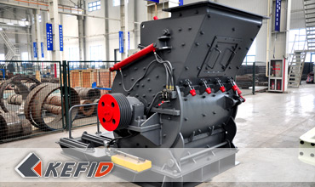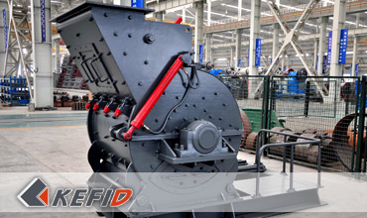

Features of European Hammer Mill
1. High production capacity and high crushing ratio.
2. Low power consumption, uniform particle size.
3. Simple, compact and light mechanical structure.
4. Low investment cost, easy management.

Working Principle of European Hammer Mill
European Hammer Mill is mainly made up of frame, rotor, hammers, grizzly bar and other components. The frame includes upper part and lower parts, which are welded by steel plates after cutting, the remaining parts bolted into one. High manganese steel liners are studded with inside the frame, to facilitate replacement for a new liners after worn; on the main shaft are installed several groups of the spindle distribution of the hammers, which consists of rotor with the axle of hammers and rotary table. The host drives the main shaft through the motor and V-belt driven spindle to rotate the rotor, generating the centrifugal force, and then driving all hammers stretch around. The bulks of material feed into the crushing chamber will be crushed by the hammers at a high-speed movement. The broken material requested will be passed the grizzly bar at the lower part and discharged, the unbroken rest will be left in the chamber to be crushed repeatedly by the hammers and iron plates until it can reach the requested standard. To avoid clogging, the water content of the material to be crushed should no more than 5%.

Technical Data of European Hammer Mill
Model | EHM4008-75 | EHM4012-90 | EHM4015-132
Diameter of the rotor (mm) | 750 | 900 | 1150
Length of the rotor(mm) | 800 | 1200 | 1500
Rotation speed of the rotor (r/min) | 800-1000 | 800-1000 | 700-1000
Input size(mm) | <70 | <90 | <100
Output size(mm) | 0-3 | 0-3 | 0-3
Capacity (t/h) | 35-50 | 50-70 | 70-100
Motor power(Kw) | 55-75 | 75-90 | 110-132
No. of the hammers(piece) | 18 | 32 | 32
Dimension(L*W*H/mm) | 2310*1665*1610 | 2840*2100*2020 | 3720*2650*2540
Note: Any change of European Hammer Mill technical data shall not be advised additionally.

Our Senior Manager
  Kevin |   Johnny |   Peter
Contact Us
Shanghai | Zhengzhou
Tel: +86-21-58385016  Fax: +86-21-58377628  E-mail: sales@kefidinc.com | Tel: + 86-371-67999255  Fax: +86-371-67998980  E-mail: david@kefidinc.com

Products | Gallery
Mobile Crushing Plant  Crawler Mobile Crusher  Mobile Jaw Crusher  Mobile Impact Crusher  Mobile Cone Crusher  Mobile VSI Crusher  Stationary Crushing Plant  Jaw Crusher  Impact Crusher  Cone Crusher  VSI Crusher  Aggregate Production Line  Stone Crushing Plant  Sand Making Plant  Grinding Mill  Vertical Mill  MTW Series Trapezoid Mill  European Hammer Mill  Micro Powder Mill  Trapezium Mill  High Pressure Mill  Raymond Mill  Ball Mill  Screening & Washing  Vibrating Screen  Screw Sand Washing Machine  Wheel Sand Washing Machine  Feeding & Conveying  Vibrating feeder  Belt Conveyor | Crushing  Mobile Crushing Plant  Stationary Crushing Plant  Jaw Crusher  Impact Crusher  Cone Crusher  VSI Crusher  Aggregate Production Line  Grinding Mill  Vertical Grinding Mill  MTW Series Trapezoid Mill  Micro Powder Mill  Trapezium Mill  High Pressure Mill  Raymond Mill  Ball Mill  European Hammer Mill  Screening & Washing  Vibrating Screen  Sand Washing Machine  Feeding & Conveying  Vibrating Feeder  Belt Conveyor  Delivery of Products  Technology  Workshop  Clients Visit and Exhibiton  Corporate Culture

