Deep Rotor VSI Crusher
Link: Gallery Get this product price
Deep rotor VSI crusher is the latest launched high efficiency equipment on the basis of fully study by the crusher expert of KEFID of production characteristics traditional VSI crusher. Deep rotor VSI crusher is the core equipment in machine-made sand industry for it contains the three crushing models.
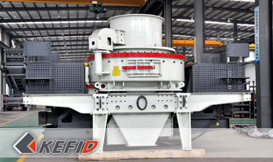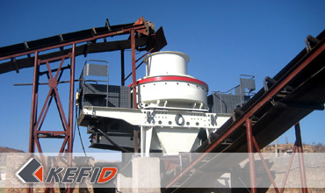

Application of Deep Rotor VSI Crusher
Deep rotor VSI crusher is widely used in various metal and nonmetal ores, cement, abrasive material, glass, construction material, machine-made sand, metallurgy, etc. It is suitable for medium and fine crushing of different hardness of varied ore and rock, such as iron ore, nonferrous ore, diamond, bauxite, quartz sand, corundum, basalt and other aggregate material’ medium and fine crushing.

Technical Data of Deep Rotor VSI Crusher
model |  | DR-7615 | DR-8522 | DR-9532 | DR-1145
Throughput capacity (t/h) | Center and Ring feeding | 150~280 | 240~380 | 350~540 | 500~640
Throughput capacity (t/h) | Center feeding | 70~140 | 120~200 | 180~280 | 250~360
Max. Feed Size (mm) | Soft material | <35 | <40 | <45 | <50
Max. Feed Size (mm) | Hard material | <30 | <35 | <40 | <45
Rotation speed (r/min) |  | 1700~1900 | 1500~1700 | 1300~1510 | 1100~1310
Power of double motor (KW) |  | 110~150 | 180~220 | 260~320 | 400~440
Overall dimension L x W x H (mm) |  | 4100×2330×2300 | 4140×2500×2700 | 4560×2600×2900 | 5100×2790×3320
Weight (t) |  | 8.6 | 11.8 | 17.5 | 27.5
Power source |  | 380v，50Hz
Thin oil lubrication station | Power for double oil pump | 2 x 0.31 KW
Thin oil lubrication station | Safety | To make sure the supply of oil with double oil pump, working without oil, temperature when water cools, start the motor by heating it in winter.
Thin oil lubrication station | Power for oil box heater | 2 KW
Thin oil lubrication station | Overall dimension  L x W x H (mm) | 820 x 520 x 1270
Note: Any change of Deep Rotor VSI Crusher technical data shall not be advised additionally.

Our Senior Manager
  Kevin |   Johnny |   Peter
Contact Us
Shanghai | Zhengzhou
Tel: +86-21-58385016  Fax: +86-21-58377628  E-mail: sales@kefidinc.com | Tel: + 86-371-67999255  Fax: +86-371-67998980  E-mail: david@kefidinc.com

Products | Gallery
Mobile Crushing Plant  Crawler Mobile Crusher  Mobile Jaw Crusher  Mobile Impact Crusher  Mobile Cone Crusher  Mobile VSI Crusher  Stationary Crushing Plant  Jaw Crusher  Impact Crusher  Cone Crusher  VSI Crusher  Aggregate Production Line  Stone Crushing Plant  Sand Making Plant  Grinding Mill  Vertical Mill  MTW Series Trapezoid Mill  European Hammer Mill  Micro Powder Mill  Trapezium Mill  High Pressure Mill  Raymond Mill  Ball Mill  Screening & Washing  Vibrating Screen  Screw Sand Washing Machine  Wheel Sand Washing Machine  Feeding & Conveying  Vibrating feeder  Belt Conveyor | Crushing  Mobile Crushing Plant  Stationary Crushing Plant  Jaw Crusher  Impact Crusher  Cone Crusher  VSI Crusher  Aggregate Production Line  Grinding Mill  Vertical Grinding Mill  MTW Series Trapezoid Mill  Micro Powder Mill  Trapezium Mill  High Pressure Mill  Raymond Mill  Ball Mill  European Hammer Mill  Screening & Washing  Vibrating Screen  Sand Washing Machine  Feeding & Conveying  Vibrating Feeder  Belt Conveyor  Delivery of Products  Technology  Workshop  Clients Visit and Exhibiton  Corporate Culture

