Belt Conveyor
Link: Gallery Get this product price
Belt conveyor mainly meet the aggregate use in different environments, the connection of the crushing and screening equipment and crushing and grinding equipment to achieve the continuity and automation of production process, improve productivity, reduce labor intensity.
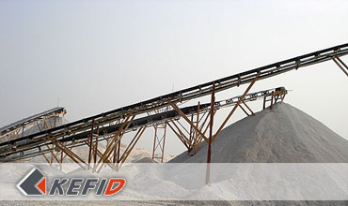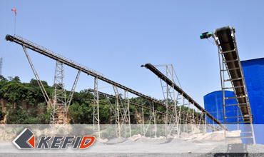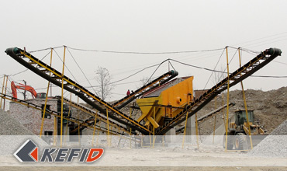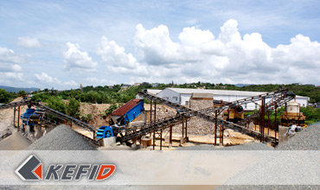

Features of Belt Conveyor
The belt conveyor moves according to the abrasion and transmission principle, which can transport a great deal of materials, transport a long way, transport stably. And there is no relative movement between materials and the belt. It has advantages of low noise, simple structure, it’s easy to maintain and has low energy consumption and standardized parts.

Application of Belt Conveyor
Belt conveyor are widely used in the transportation equipment sector, such as the chemical industry, coal, metallurgy, mining, foundry, building materials, power, light, food, transportation, production lines and construction of hydropower stations and ports and other production sites. According to transportation technology requirements, the transfer system can be one or multi-conveyor or combined with other transfer equipments to meet the different layout of the operating line needs.
Belt conveyor can be operated in the circumstance temperature from -20℃ and to 40℃, the temperature of transferred material should be lower than 50℃. The conveyor length can be manufactured according to the needs of users.

Working Principle of Belt Conveyor
The belt conveyor is composed of frame, transferring belt, belt roller, intensive device, transmission device and so on. The machine body is made of high-quality steel plate joint. Frame is formed by height difference of front and back supporting legs, the category is a tilt with certain angle. On the frame, there are belt roller, carrier roller and so on for driving and supporting conveyor belt. There are two methods, driven by speed reducer and electric drum.

Technical Data of Belt Conveyor
Belt Width(mm) | Belt Length (m) / Power (kW) |  |  | Belt Speed (m/s) | Capacity (t/h)
500 | ≤12/3 | 12-20/4-5.5 | 20-30/5.5-7.5 | 1.3-1.6 | 45-100
650 | ≤12/4 | 12-20/5.5 | 20-30/7.5-11 | 1.3-1.6 | 70-120
800 | ≤10/4 | 10-15/5.5 | 15-30/7.5-15 | 1.3-1.6 | 120-180
1000 | ≤10/5.5 | 10-20/7.5-11 | 20-40/11-22 | 1.3-2.0 | 160-250
1200 | ≤10/7.5 | 10-20/11 | 20-40/15-30 | 1.3-2.0 | 200-400
Note: Any change of Belt Conveyor technical data shall not be advised additionally.

Our Senior Manager
  Kevin |   Johnny |   Peter
Contact Us
Shanghai | Zhengzhou
Tel: +86-21-58385016  Fax: +86-21-58377628  E-mail: sales@kefidinc.com | Tel: + 86-371-67999255  Fax: +86-371-67998980  E-mail: david@kefidinc.com

Products | Gallery
Mobile Crushing Plant  Crawler Mobile Crusher  Mobile Jaw Crusher  Mobile Impact Crusher  Mobile Cone Crusher  Mobile VSI Crusher  Stationary Crushing Plant  Jaw Crusher  Impact Crusher  Cone Crusher  VSI Crusher  Aggregate Production Line  Stone Crushing Plant  Sand Making Plant  Grinding Mill  Vertical Mill  MTW Series Trapezoid Mill  European Hammer Mill  Micro Powder Mill  Trapezium Mill  High Pressure Mill  Raymond Mill  Ball Mill  Screening & Washing  Vibrating Screen  Screw Sand Washing Machine  Wheel Sand Washing Machine  Feeding & Conveying  Vibrating feeder  Belt Conveyor | Crushing  Mobile Crushing Plant  Stationary Crushing Plant  Jaw Crusher  Impact Crusher  Cone Crusher  VSI Crusher  Aggregate Production Line  Grinding Mill  Vertical Grinding Mill  MTW Series Trapezoid Mill  Micro Powder Mill  Trapezium Mill  High Pressure Mill  Raymond Mill  Ball Mill  European Hammer Mill  Screening & Washing  Vibrating Screen  Sand Washing Machine  Feeding & Conveying  Vibrating Feeder  Belt Conveyor  Delivery of Products  Technology  Workshop  Clients Visit and Exhibiton  Corporate Culture

