Ball Mill
Link: Gallery Get this product price
Ball mill is suited for milling various kinds of minerals and other materials. It is divided into two kinds of types, dry grinding and wet grinding. Ball mill is the key device for the materials to be grinded after being crushed. Ball mill is widely used in the mineral separation, construction materials, and chemical industry, and so on.
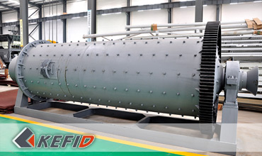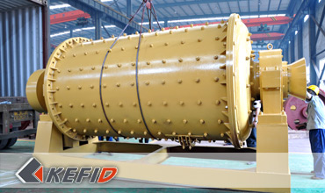

Application of Ball Mill
Ball mill is widely used for cement, silicate products, new building material, fireproof material, chemical fertilizer, ferrous and non-ferrous metal mineral dressing and glass-ceramic areas. Totally, it is used for dry or wet milling for various materials.
The machine consist of feeding part, discharging part, rotary division, transmission division(speed reducer, small transmission gear, electric motor, drive-by-wire)and other main parts. The quill shaft adopts cast steel and replaceable lining. Slewing gear adopts casting hobbling processing. There inlay wearing-resistant lining board in the barrel, which has favorable abrasive resistance. Ball mill operates smoothly and reliable.

Technical Data of Ball Mill
Model | Speed of  bucket (r/min) | Weight of ball (t) | Size of feed  opening (mm) | size of outputting  feed (mm) | Production (t/h) | Power (kW) | Weight (t)
Ф900×1800 | 38 | 1.5 | ≤20 | 0.075-0.89 | 0.65-2 | 18.5 | 3.6
Ф900×3000 | 38 | 2.7 | ≤20 | 0.075-0.89 | 1.1-3.5 | 22 | 4.6
Ф1200×2400 | 32 | 3.8 | ≤25 | 0.075-0.6 | 1.5-4.8 | 45 | 12.5
Ф1200×3000 | 32 | 5 | ≤25 | 0.075-0.4 | 1.6-5 | 45 | 12.8
Ф1200×4500 | 32 | 7 | ≤25 | 0.075-0.4 | 1.6-5.8 | 55 | 13.8
Ф1500×3000 | 27 | 8 | ≤25 | 0.075-0.4 | 2-5 | 90 | 17
Ф1500×4500 | 27 | 14 | ≤25 | 0.075-0.4 | 3-6 | 110 | 21
Ф1500×5700 | 27 | 15 | ≤25 | 0.075-0.4 | 3.5-6 | 132 | 24.7
Ф1830×3000 | 24 | 11 | ≤25 | 0.075-0.4 | 4-10 | 180 | 28
Ф1830×6400 | 24 | 23 | ≤25 | 0.075-0.4 | 6.5-15 | 210 | 34
Ф1830×7000 | 24 | 25 | ≤25 | 0.075-0.4 | 7.5-17 | 245 | 36
Ф2200×5500 | 21 | 30 | ≤25 | 0.075-0.4 | 10-22 | 370 | 48.5
Ф2200×6500 | 21 | 30 | ≤25 | 0.075-0.4 | 14-26 | 280 | 52.8
Ф2200×7500 | 21 | 33 | ≤25 | 0.075-0.4 | 16-29 | 380 | 56
Φ2200×9500 | 21 | 38 | ≤25 | 0.074-0.4 | 18-35 | 475 | 62
Note: Any change of Ball Mill technical data shall not be advised additionally.

Our Senior Manager
  Kevin |   Johnny |   Peter
Contact Us
Shanghai | Zhengzhou
Tel: +86-21-58385016  Fax: +86-21-58377628  E-mail: sales@kefidinc.com | Tel: + 86-371-67999255  Fax: +86-371-67998980  E-mail: david@kefidinc.com

Products | Gallery
Mobile Crushing Plant  Crawler Mobile Crusher  Mobile Jaw Crusher  Mobile Impact Crusher  Mobile Cone Crusher  Mobile VSI Crusher  Stationary Crushing Plant  Jaw Crusher  Impact Crusher  Cone Crusher  VSI Crusher  Aggregate Production Line  Stone Crushing Plant  Sand Making Plant  Grinding Mill  Vertical Mill  MTW Series Trapezoid Mill  European Hammer Mill  Micro Powder Mill  Trapezium Mill  High Pressure Mill  Raymond Mill  Ball Mill  Screening & Washing  Vibrating Screen  Screw Sand Washing Machine  Wheel Sand Washing Machine  Feeding & Conveying  Vibrating feeder  Belt Conveyor | Crushing  Mobile Crushing Plant  Stationary Crushing Plant  Jaw Crusher  Impact Crusher  Cone Crusher  VSI Crusher  Aggregate Production Line  Grinding Mill  Vertical Grinding Mill  MTW Series Trapezoid Mill  Micro Powder Mill  Trapezium Mill  High Pressure Mill  Raymond Mill  Ball Mill  European Hammer Mill  Screening & Washing  Vibrating Screen  Sand Washing Machine  Feeding & Conveying  Vibrating Feeder  Belt Conveyor  Delivery of Products  Technology  Workshop  Clients Visit and Exhibiton  Corporate Culture

